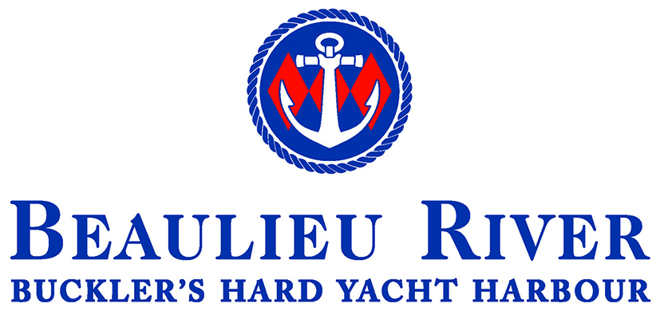

Job Title: Marine Operative, Beaulieu River

Salary: £27,000 - £31,760 Depending on experience

Hours: 40 per week

Employer: Beaulieu Enterprises Ltd

Reporting to: Deputy Harbour Master
Overall:

- To assist the boatyard team in the lifting, launching and storage of all vessels within the Buckler’s Hard Yacht Harbour.

- To assist with the patrolling of the Beaulieu River to ensure that the river operates as efficiently and safely as possible in accordance with the Port Marine Facilities Safety Code

Key Duties:

- To assist with the lifting/washing, blocking off, cross-bracing and launching of boats as required.
- To act as visual monitor during boat hoist movements.
- To assist with the un-stepping and re-stepping of boat masts as and when required.
- Check boats stored ashore regularly especially when extreme weather is forecast.
- To make sure all blocks, shores and wedges are stored in their respective areas.
- To deputise for the Boatyard Supervisor in their absence
- To assist with the collection and return of boats from berths as and when required, ensuring they are berthed as per the customer’s instructions.
- To notify the Deputy Harbour Master of any incidents, maintenance requirements as and when required.
- To ensure all persons operating within the yard are adhering to the safety notes. If not, to report any incidents / contractors that are not following health & safety procedures.
- To assist with maintaining the yard and marina in a clean and tidy condition and carry out regular inspections of all areas. To report any maintenance that is required.
- To assist with the patrolling of the Beaulieu River to ensure that the harbour operates as efficiently and safely as possible in accordance with the Port Marine Safety Code.
- Collect Harbour Dues from the marina and river and sell fuel.
- To ensure the highest standards of service to customers, protecting the reputation of the company at all times.
- To assist with the maintenance, repair and servicing of all mooring tackle as required.
- To carry out all duties in a way which will ensure the Health and Safety of staff and visitors is adhered to.
- To undertake any other duties as required by the Harbour Master or Deputy Harbour Master.

Person specification:

Essential

Experience in the operation of boat handling, crane and machinery operations and storage of boats.
A Full UK Driving Licence
To be customer focused
Be prepared to work outdoors in all conditions
Physical Fitness and ability to undertake outdoor physical work
Able to swim
Basic Clerical and keyboard skills
Cash handling
Ability to work unsupervised
Ability to communicate tactfully and diplomatically at all levels

Desirable

NPORS Boat Hoist qualified
RYA Level 2 Powerboat Certificate
Fork Lift/telehandler Qualifications
First Aid at Sea
VHF Short Range Radio Licence

To apply for this position please forward your CV and a covering letter to recruitment@beaulieu.co.uk
Closing date: 11th May 2026

