
Appointment Brief
Financial Director, Beaulieu Enterprises Ltd
Introduction & Background

The overall Beaulieu Estate vision is: To build the Estate as an environmentally, socially and economically sustainable entity in family ownership for future generations.
Beaulieu Enterprises Ltd (BEL) exists to further the commercial objectives of the Beaulieu Estate. It contributes to the economic sustainability, provides local employment and funds maintenance of several of the key assets.
BEL operates the following business units:

- Beaulieu Visitor Attraction including the National Motor Museum, Palace House & Beaulieu Abbey, welcoming 340,000 visitor per annum for day visits and events. www.beaulieu.co.uk.
- Beaulieu River, with a 200 berth yacht harbour, 300 moorings, a 90 boat trailer park as well as a boatyard and chandlery. www.beaulieuriver.co.uk.
- Buckler’s Hard village visitor site, welcoming 100,000 visitors per annum. www.bucklershard.co.uk.

In this interesting and diverse role you would act as Finance Director to BEL and manage the accounting service to the Beaulieu ‘family’ of organisations as follows:

- The Beaulieu Estate
- Beaulieu Enterprises Ltd
- The National Motor Museum Trust (and trading subsidiary)
- Vintage Tyre Supplies Ltd
- The Countryside Education Trust
- The Beaulieu Chattels Partnership

These organisations are bound together by being based on the Beaulieu Estate with Lord Montagu as chairperson. They include commercial companies, charities, a partnership and a private estate.

We are looking for someone who wishes to be very much involved in the running of the business, not just the finances. You will be involved in all key decisions.

Key objectives of role

- To oversee all financial and accounting processes for Beaulieu Enterprises and the family of Beaulieu organisations.
- To ensure that the financial affairs of Beaulieu are managed effectively with appropriate financial controls in place.
- To lead the finance, IT and HR teams.
- To provide sound financial guidance to colleagues, be a member of the Beaulieu senior management team and attend board meetings.
- Contribute to the long term success of the Beaulieu Estate.

Key responsibilities of role

The Financial Director will be responsible for:
- Ensuring appropriate financial controls and budgetary systems are in place.
- The provision of timely and relevant financial information and KPIs for all organisations, including management accounts and weekly figures.
- The preparation of year-end accounts and liaison with auditors.
- The payroll function.
- Managing cash flow and liaising with bankers to secure ongoing finance.
- Tax compliance including VAT, PAYE, Corporation Tax, Income Tax and Gift Aid.
- Input to tax planning strategy, with a view to leading the strategy longer term.
- The maintenance of adequate fixed asset records.
- Managing the IT function.
- Managing the HR function.
- Attendance at Board and Committee meetings for the Beaulieu ‘family’ of organisations.
- Ensuring that services delivered to the organisations meet the agreed service levels.
- Insurance arrangements, including liaison with brokers, claims administration and associated risk management.
- Administration of the final salary and personal pension arrangements as well as Healthcare and Group Life schemes.
- Assisting managers in the interpretation of accounts and financial data in order to achieve budgets and make sound commercial decisions.
- Liaising with lawyers and other advisors where advice is needed.
- Acting as Data Controller, responsible for GDPR compliance for Beaulieu Enterprises, Beaulieu Estate and the National Motor Museum.
- Reviewing and approving supplier and customer contracts and terms and conditions.
- Acting as ‘Duty Officer’ for the visitor sites on a rota basis, including some weekends. We have a senior manager on site on most days to provide support and ensure standards are maintained.
- Other duties as may be reasonably required.

Departmental chart

This role is responsible for the following staff:
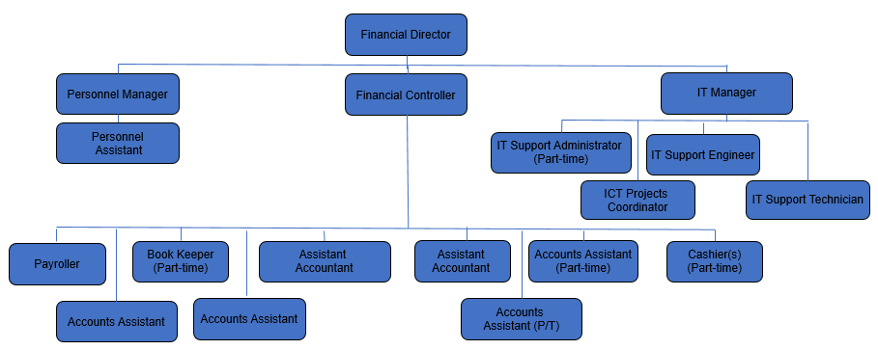

BEL senior team

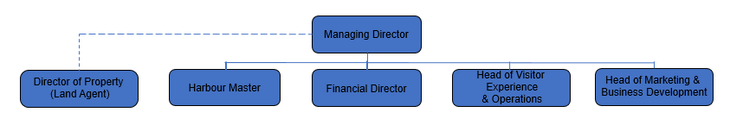

Person specification

We are open to considering applications from people with enthusiasm and experience relevant to this role. This person might look as follows in regards to qualifications, experience, skills and knowledge, but if you don’t quite tick all the boxes yet feel you could be excellent in this role, please do apply.
- Qualified Accountant.
- At least 5 years PQE probably in a commercial environment, with strong technical skills.
- Sound business and financial planning skills.
- A proven ability to lead, motivate and develop staff and to build strong and trusted relationships.
- Commercially minded, yet sensitive to the requirements of not for profit entities.
- Understand the way in which charities work.
- Have worked in a collaborative cross-disciplinary environment.
- Enthusiastic to contribute to the success of the organisation you work for.

Terms of appointment

The post holder is required to work such hours as the post demands including some weekends and evenings. Minimum hours 37.5 per week. Some home working is permitted but the post holder is required to work primarily from Beaulieu.

Employer: Beaulieu Enterprises Ltd
Line Manager: Managing Director
Salary: £80,000 - £90,000 per annum.
Holiday: 25 days per annum, plus bank holidays, plus bonus birthday day off!
Group personal pension with contribution of 10% by employer and 5% by employee.
Private healthcare cover for the post holder.
Employee Assistance Programme for work and non-work related support.
Other benefits: free onsite car parking, shop and catering discount, free family admission to Beaulieu and Buckler’s Hard.
Working with a nice bunch of people.

In keeping with the long term nature of this important role we expect a 6 month notice period.
We believe we offer a friendly work environment.

How to find out more and apply:

You are welcome to have an informal chat with the current incumbent or the MD. Please email to book a time.

HR: lisa.gridley@beaulieu.co.uk
MD: russell.bowman@beaulieu.co.uk

To apply, please email your CV in confidence to recruitment@beaulieu.co.uk or call 07818 454539

CLOSING DATE 18 MARCH 2024 – FIRST INTERVIEWS – 27 MARCH 2024




