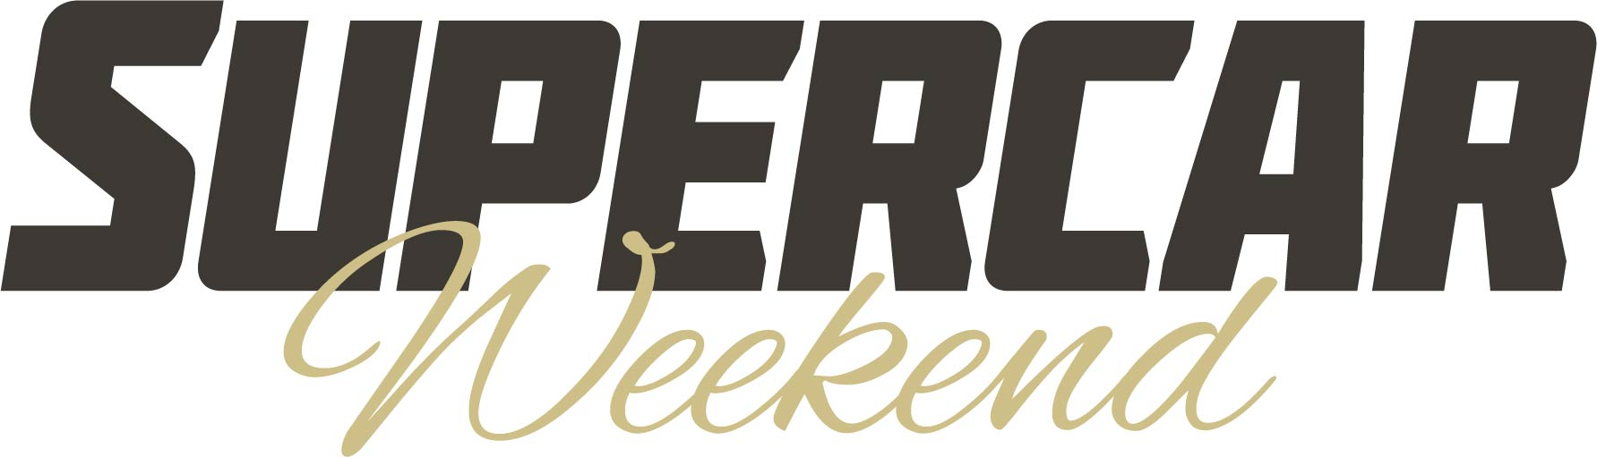
Snap up the last few Supercar Weekend early bird tickets now!

The last few early bird tickets for the 2024 Beaulieu Supercar Weekend are still available to buy, but with the last few hundred discounted tickets left out of a limited run of just 1,000, they won’t hang around for long! What better excuse to blast away the winter blues by booking ahead for this great summer event, with plenty of high-octane thrills to look forward to.
Get ahead of the game and book now by visiting www.beaulieusupercarweekend.co.uk.
Bringing even more automotive excitement to the grounds of the National Motor Museum, the Beaulieu Supercar Weekend will be making its greatly anticipated return on Saturday 3rd and Sunday 4th August, with an awesome selection of some of the world’s most desirable and exclusive supercars.
Great displays will be building on the success of last year’s show. The lawns around Palace House will play host to the Hypercar and Prestige display, sparkling with a selection of some of the world’s most impressive cars, including the private lawns which were a big hit with showgoers when opened up by Lord Montagu for the first time for last year’s show.
Among the first of the unique machines booked in to go on display is a Pagani Huayra Roadster, the final one built of a limited production run of just 100 and with striking yellow trim in contrast to its Mamba Black exposed carbon bodywork.
Long-time event supporter, Brookspeed, will be showcasing a selection of supercars and their racing counterparts. From McLaren and Porsche to a Daytona Cobra, look out for an amazing line-up of road and race cars parked at the show.
For the first time, Indigo Blue European will be the transport partner for the Beaulieu Supercar Weekend. Offering transport solutions and specialised car storage around the UK and further afield, the Indigo Blue European team will be at the show with a display of customers’ special high-performance vehicles.
The paddocks will be filled with awesome motors, from lightweight, high-revving performance cars to huge-engined monsters, with a selection taking to Beaulieu’s Chestnut Avenue for the supercar parades, or treating showgoers to the sound of their engines in the hugely popular sound-off.
Show favourites the Sporting Bears Motor Club will once again have a strong presence at the show with a wide variety of exciting cars, raising money for charity by raffling off rides and collecting money through photo opportunities.
The Beaulieu Supercar Weekend is just one of the great events taking place at Beaulieu this year. For details on the full events calendar, visit www.beaulieu.co.uk/events.

– ENDS –

Further information from:
Ben Coleman Richard Morgan
Marketing Executive Marketing Manager
E: ben.coleman@beaulieu.co.uk E: richard.morgan@beaulieu.co.uk
T: 07900 264393 T: 07818 454502

