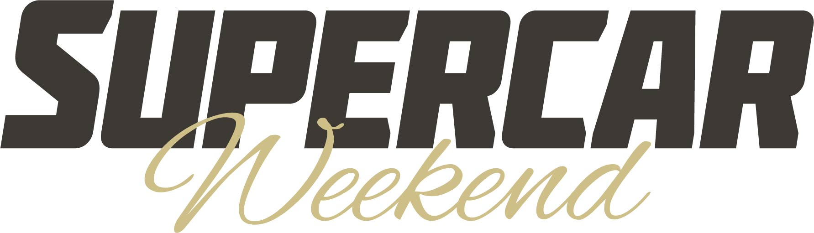
Incredible supercars, special guests and unforgettable displays at the Beaulieu Supercar Weekend

Stunning supercars stole the show at the Beaulieu Supercar Weekend on 5th and 6th August, as visitors admired impressive displays and action-packed demonstrations throughout the weekend. The showground was alive with the sounds, sights and smells of high-powered motors, while BBC Top Gear’s The Stig made a special guest appearance, all making the 2023 show one of the best ever.
With nearly 18,000 show-goers heading to Beaulieu for the two-day show, a crowd-pleasing favourite that celebrated the excitement and variety of the supercar world was the demonstration run. As a wide variety of epic machines display their impressive acceleration and braking abilities on Beaulieu’s Chestnut Avenue, spectators lined the route to cheer on the drivers, while the big screen on the Arena broadcast the action live.
From lightweight, high-revving performance cars to huge-engined monsters, all kinds of machines took to the track. Amongst the Lamborghinis, Ferraris, McLarens, Porsches and more that wowed the crowds, with their ear-splitting exhausts and squealing tyres, The Stig put a prototype Ford Mustang Dark Horse through its paces on both days.
The mysterious driver demonstrated his legendary driving skills by performing crowd-pleasing burnouts, stopping at the half-way point to get out of the car and stand face-to-face with the cheering spectators. Attending the show with BBC Top Gear Magazine, The Stig also met with visitors and posed for free photos during the weekend outside Beaulieu’s World of Top Gear… but didn’t have much to say!
Celebrating 60 years of Lamborghini, a parade lap of the demonstration run saw a line-up of Lamborghini models create a moving time-line. The line-up included a Muira, Countach, LM002 and even a Lamborghini tractor, from the firm’s agricultural machinery past.
Beaulieu Events Manager Charlotte Mountain said: “It was wonderful to see thousands of supercar drivers and enthusiasts out in full force across the whole weekend. Despite the damp weather on Saturday, it didn’t stop showgoers attending the event to watch the demonstration runs and sound-off. A big thank to all the drivers that made the show such a successful one and we look forward to welcoming them all back in 2024.”
Another special guest was motorsport rising star Gus Burton. The 2022 Porsche Carrera Cup GB Rookie Champion, attending the show with Supercar Paddock Drivers’ Marquee sponsors NFU Mutual, had brought along his racing Porsche for visitors to admire. Gus was interviewed by the show’s commentator Tim Watson on the Arena, chatting about his time in motor racing and sharing some of his tales of the track, and also took part in the demonstration run in his father’s Aston Martin.
Another treat for show-goers was the supercar sound-off, which pitted the raucous exhaust sounds of a wide selection of supercars against each other, with the loudest cheer from the audience deciding which one sounded best. Winning the sound-off trophy on the Saturday was a Ford Mustang, while on Sunday an Ultima GTR was victorious.
The lawns around Palace House sparkled with some of the world’s most impressive cars. 25 Ferraris came together for the impressive Ferrari on the Lawn display, ranging from a 330 P4 replica to a Dino, 250 GTE, F40, Daytona and LaFerrari.
For the first time ever, the private lawns of Palace House were also opened up to visitors, as the picturesque location of the new Hypercar Lawn display. Set against the historic backdrop of the Montagu family home were such jaw-dropping machines as a Bugatti Chiron, one of the most extraordinary cars ever built, and a Koenigsegg Agera S ‘Green Goblin’, one of only 5 built, along with a McLaren Senna, Jaguar XJ220, Porsche 959, McLaren MSO1 and more.
The impressive displays continued with a line-up of McLarens to mark 60 years of McLaren, while a line-up of four classic De Tomasos along the side of Palace House, and a selection of Ford GT40 replicas on the Arena, were additional delights for historic supercar fans.
The Supercar Paddocks were a must-see, with colourful club line-ups and a broad selection of supercars brought along by individual owners. From Porsche, Lamborghini, Aston Martin, Honda and Mercedes, to TVR, Noble, Lotus, Ultima, Morgan, AC, Ariel and more, all manner of high-performance motoring marques were represented across the packed showground.
Show favourites the Sporting Bears Motor Club had a strong presence at the show with a wide variety of exciting cars, raising money for children’s charity Simon Says by raffling off rides and collecting money through photo opportunities. While Supercar-driving influencer and YouTuber Sam Fane from Seen Through Glass joined the Saturday show line-up in his Porsche, chatting with other enthusiasts and enjoying the displays.
The Beaulieu Supercar Weekend will return for 2024, with dates to be announced later this year. For details on Beaulieu’s events calendar, visit www.beaulieu.co.uk/events.

– ENDS –

Further information from:
Ben Coleman Richard Morgan
Marketing Executive Marketing Manager
E: ben.coleman@beaulieu.co.uk E: richard.morgan@beaulieu.co.uk
T: 07900 264393 T: 07818 454502

