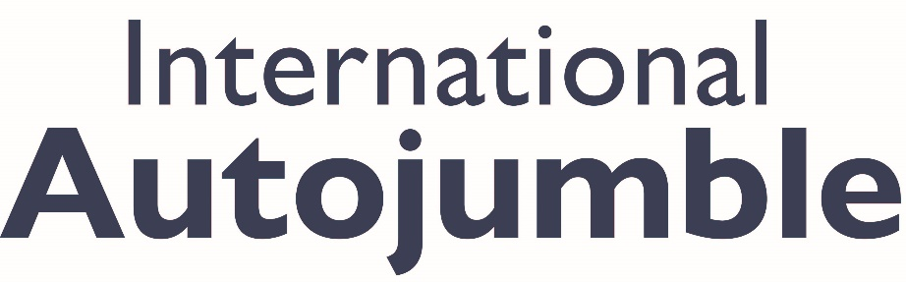
Expert talks and great buys for Beaulieu’s International Autojumble
September 2nd & 3rd
Experts from across the motoring world will be sharing their specialist knowledge at Beaulieu’s International Autojumble, as the packed weekend show returns to the home of the National Motor Museum on 2nd and 3rd September.
Throughout the busy weekend, the brand new In Conversation With… feature, sponsored by Lancaster Insurance, will give showgoers the chance to join a variety of Q&A drop-in sessions on a variety of topics. With special guests giving illuminating talks on fascinating subjects, these 45 minute drop-in sessions will be a must-see element of the show. More details to be announced soon.
With all the buying, selling and automotive enjoyment which International Autojumble is famous for, the show will be the place to search for bargains and great buys. From spare parts for historic vehicles, to motoring books, model cars, vintage clothing, signs, collectables, automobilia and even complete vehicles, you’ll be spoiled for choice.
The Bonhams | Cars auction will be taking place at the show on Saturday 2nd, with collectors’ cars, motorcycles and automobilia all going under the hammer. While Automart is the perfect opportunity to sell your classic or vintage car or bike, showcasing it to thousands of potential buyers of the course of the weekend. With a car space also including weekend entry to the show and the whole Beaulieu attraction, it’s a great way to get involved with the big motoring-themed weekend.
For more motors on sale, make sure to look at Dealermart, with top condition classics on offer from traders. While on Sunday Trunk Traders offers the chance to find bargains as enthusiasts sell assorted motoring jumble from their car boots.
Show media sponsor Practical Classics magazine will also be there, as the team talks to showgoers and discusses automotive projects past, present and future.
Advance one-day and two-day visitor tickets are available, with a limited number of premium tickets giving priority parking, early showground entry and a complimentary Showguide. For more details and to book your tickets, visit beaulieu.co.uk/events/international-autojumble/tickets. Exhibitors and Trunk Traders can book their stands online at beaulieu.co.uk/events/international-autojumble/exhibitors or contact the events team at events@beaulieu.co.uk or 01590 614614.
Visitor and participant tickets include entrance to all that Beaulieu has to offer. Make sure to explore the National Motor Museum, as well as Little Beaulieu, World of Top Gear, On Screen Cars, the ancestral Montagu home Palace House, Secret Army Exhibition, 13th century Beaulieu Abbey and the stunning grounds and gardens. Visit beaulieu.co.uk for more information.

– ENDS –

Further information from:
Ben Coleman Richard Morgan
PR Executive Marketing Manager
E: pr@beaulieu.co.uk E: richard.morgan@beaulieu.co.uk
T: 01590 614641 T: 07818 454502

