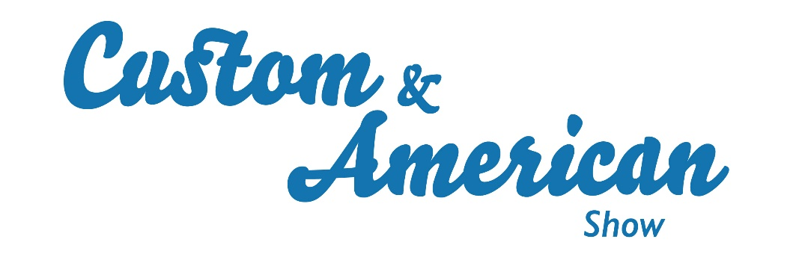

20th June 2023

Amazing motors and live music for Beaulieu’s 2023 Custom and American Show
Over 5,600 visitors and participants made Beaulieu their Father’s Day destination for the Custom and American Show, enjoying the colourful line-up of 406 customised and American cars and bikes, alongside live music, trade stands, and all the features of the Beaulieu attraction.
Held in association with the Solent Renegades club, the top display on Sunday 18th June gathered together American cars and bikes as diverse as a pre-war Ford Model A and a modern-day Humvee, not to mention 1970s muscle cars, 1950s sedans, and even a trio of trucks which towered over the other vehicles. While jaw-dropping custom trikes, powerful hot rods and all manner of impressive custom cars also turned heads as they parked up in the grounds of the National Motor Museum.
See the show highlights by watching the video, youtu.be/Vuenn6NVRCM
While showgoers admired the display, talked cars, browsed trade stands and enjoyed delicious street food, and youngsters had their faces painted, the Honky Tonk Angels and Rooster Live took to the stage, performing great rock and roll numbers throughout the day.
A highlight for many custom car fans was the chance to meet show ambassador and custom car builder Andy Saunders, who had brought along his latest creation, Deja. Four years since he first exhibited his Riley at the show, the once-derelict car has been totally transformed into a stunning open-top show car. Andy chatted with other enthusiasts about their projects and signed copies of his book, while artist Maxime Xavier had brought along her stunningly airbrushed custom car Sundancer.
Just as eye-catching was a quartet of replica TV and film vehicles, with full-size recreations of the much-loved Lightning McQueen and Tow Mater characters from Pixar’s Cars movies, and replicas of the iconic A-Team van and Del Boy’s van from Only Fools and Horses, proving to be a big hit with families. While fitting with the silver-screen theme, Hollywood-style stars with the names of famous movie vehicles were laid on the main footpath to create Beaulieu’s own ‘walk of fame’.
Awards were presented to a selection of impressive vehicles. The People’s Best in Show, voted for by showgoers, was presented to Debbie and Pete Whiffin from Guildford for their 1955 Buick Century. As Beaulieu’s Head of Visitor Experience and Operations Manager Jon Tee presented them with their trophy and Autoglym prize, Debbie said: “We bought the car two years ago and imported it from the States, before doing lots of mechanical work to it. This is the first time we’ve been out in it!”
Presented by the show ambassador, The Andy Saunders Award went to Teri Smith from Christchurch for his 1935 Ford Cabriolet. As he handed Teri his trophy, Andy said: “The reason this car is so important in the custom scene, is that these wide-bodied Fords, brought out in 1935, were modified to become the first custom cars, whereas everything built up to 1934 became hot rods.” Teri said: “I’m amazed to have won this award. I’ve had it five years, and it has had a complete rebuild. It’s something different, our own creation.”
The Solent Renegades’ Choice was presented by club representatives Dan and Malcolm to Alan Fee from Cadnam for his 1970 Dodge Challenger. Malcolm said: “It was a nightmare choosing a winner. But when we saw this car, we just stopped in our tracks, and couldn’t stop looking at it.” Alan said: “I’m surprised to have won! I’ve done a lot to the car in the time I’ve had it.” Dan and Malcolm presented Alan with a trophy and an Autoglym prize.
Classic American magazine held one of the heats for its Car of the Year competition at the show, selecting Andrew and Lynda Collier’s 1955 Cadillac Eldorado Convertible as the heat winner. Presented with their trophy by Classic American editor Ben Klemenzson and Hollie Cowley from Kingstown Shipping, Andrew said “I had a photo of one of these Cadillacs on my wall when I was growing up. Now that we have one in the garage, I can just pull up a chair, put on some music and look at the car.”
Entered by his family, Daniel Adams won the special Father’s Day show prize draw out of almost 120 contestants, being presented by a special hamper of Beaulieu gifts by Beaulieu’s Head of Visitor Experience and Operations Manager Jon Tee.
The Custom and American Show is just one of Beaulieu’s exciting 2023 motoring events. For Beaulieu’s full event calendar, visit www.beaulieu.co.uk/events.

– ENDS –

Further information from:
Ben Coleman Richard Morgan
Marketing Executive Marketing Manager
E: pr@beaulieu.co.uk E: richard.morgan@beaulieu.co.uk
T: 01590 614641 T: 07818 454502

