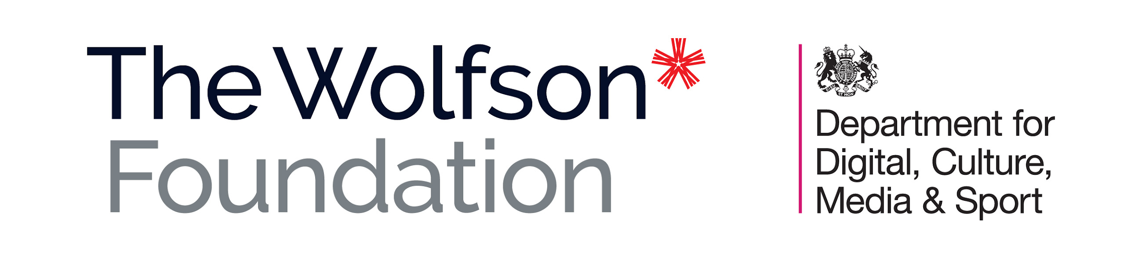
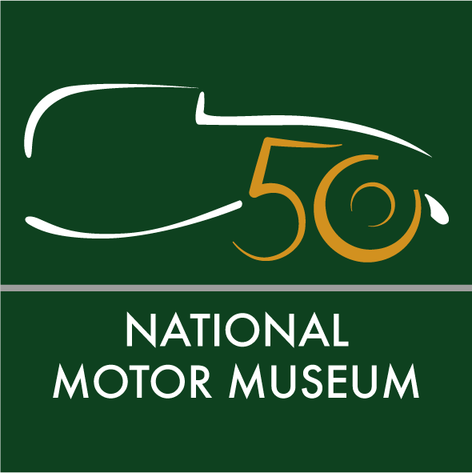
Media news
December 7, 2022

National Motor Museum wins major funding for first phase of ambitious plans for a bright new future

The National Motor Museum at Beaulieu will start work in 2023 to take it forward for the next 50 years after being awarded a £200,000 grant from the Department for Digital, Culture, Media & Sport (DCMS) and The Wolfson Foundation through the DCMS/Wolfson Museums and Galleries Improvement Fund 2022-24
National Motor Museum Trust fundraising will now begin to match the grant with its own contribution towards the Motoring into the Future project – to transform the museum entrance and initial exhibition areas, for a more engaging and interactive start to its visitor journey.
As phase one of a four-phase scheme, the ambitious new plans set out the future of the National Motor Museum which celebrated its landmark 50th anniversary this year.
National Motor Museum Trust Chief Executive Jon Murden said: “This is exciting news and I am glad that we are on our way to a bright new future for the National Motor Museum. This major grant will enable us to start the first phase of our planned works next year. It is the first step on a long road, with bold plans to raise £15-20 million over the next seven years to fully realise our ambitions.
“We must improve our museum spaces, equipment and interpretation for younger visitors, as well as upgrade facilities for the conservation and restoration of our 285 display vehicles. We also plan to open up our internationally-acclaimed stored collections of more than 1.9 million items of automobilia, and make them accessible for everyone to see. The world of motoring is rapidly changing and we must keep pace to tell its story.”
Phase one of the project will transform the entrance gallery into a new welcome area, where visitors can learn about the museum’s foundation. Two further galleries will be combined into a large exhibition space to tell the remarkable story of motoring from its beginnings to its present and future, as well as the shared experience of its impact on all of our lives. Themed galleries will remain on the lower and raised mezzanine floors. To make the museum more accessible for everyone, heavy entrance glass doors will be replaced with user-friendly, power-assisted alternatives.
If you can help to support the fundraising, please contact Michelle Kirwan, Head of Development at the National Motor Museum Trust, at michelle.kirwan@beaulieu.co.uk.
For further information about the National Motor Museum, its plans for the future, collections, research service and education programme visit www.nationalmotormuseum.org.uk.
Ends
Note to editors:

National Motor Museum

The National Motor Museum is an Accredited Museum and all of its collections have been designated by Arts Council England as being of national and international importance. Inspiration for the museum came from motoring pioneer and transport visionary John 2nd Baron Montagu. His son Edward, Lord Montagu first displayed five cars in the entrance hall of Palace Hall as a tribute to his father, before opening the museum on July 4th, 1972. Together, their legacy resulted in the foundation of the first permanent national motor museum in the world.

Beaulieu

Explore The Story of Motoring in 50 Objects in the National Motor Museum as part of a marvellous day out to Beaulieu that all the family will enjoy together. See the World of Top Gear, On Screen Cars and ride on a ‘skytrain’ monorail. Have big fun in Little Beaulieu's adventure play area, experience life ‘upstairs and downstairs’ in Palace House, walk in the footsteps of monks at Beaulieu Abbey, find out about special agents in the Secret Army Exhibition and saunter through the beautiful grounds and gardens – all in one ticket to Beaulieu. For tickets and details see www.beaulieu.co.uk or call 01590 612345.

DCMS/Wolfson Museums and Galleries Improvement Fund

Museums and galleries across England applied for a share of £4 million of new funding to improve displays, protect collections and make exhibitions more accessible to visitors. The cash boost has been added to the joint DCMS/Wolfson Fund as the fund marks 20 years of the two organisations working together to support the arts and culture.

Both DCMS and The Wolfson Foundation contributed £2 million through their partnership, which is committed to improving collections and exhibitions in museums and galleries across the country.

Over the last 20 years the fund has awarded £48 million to over 400 projects at museums and galleries.

Further information from:
Jane Riddiford Rachael Goldstraw
Public Relations Head of Marketing and Business Development
Tel: 07818 454513 Tel: 07500 882224
Email: Jane.riddiford@beaulieu.co.uk Email: Rachael.Goldstraw@beaulieu.co.uk

