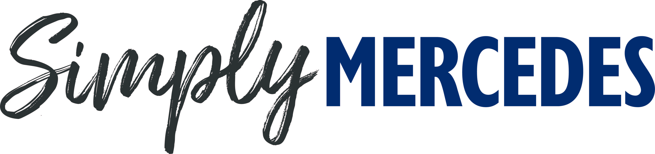

Mercedes magic for Beaulieu’s Simply Mercedes
Sunday 21st August
Mercedes cars will be the stars of the show as Beaulieu’s Simply Mercedes returns for its fourth year on Sunday 21st August, with an impressive line-up in the grounds of the National Motor Museum.
From luxury saloons to glamorous sports cars and even rugged vans and utility vehicles, look out for all manner of high-quality motors wearing the famous three-pointed star badge, as they park up in the show, as part of this motoring themed day out that all the family will enjoy.
From impressive classics to their high-performance modern counterparts, last year’s show gave a snapshot of the rich variety of Mercedes on the roads. This year’s display promises to be just as varied, with the chance to admire all manner of Mercedes on show.
Make sure to head inside the National Motor Museum to see Beaulieu’s replica 1886 Benz Patent-Motorwagen, ancestor to the modern-day Mercedes and representing a key moment in the development of the motor car. This fascinating machine is just one of the objects in the brand new exhibition, The Story of Motoring in 50 Objects, which celebrates the 50th anniversary of the National Motor Museum.
For more Mercedes magic inside the museum, look out for the stylish 1928 Mercedes-Benz Model S 36/220, along with the 1903 Mercedes 60hp and 2006 McLaren Mercedes MP4/21 F1 show car, very different but equally fascinating machines at opposite ends of motoring history.
Event-goers can vote for their favourite Mercedes of the show in the People’s Choice Award, with the winner receiving a Beaulieu trophy and an Autoglym prize. Voting is open to all visitors until 1pm that day, with the presentation taking place at 2pm.
Participants are encouraged to buy their tickets in advance at beaulieu.co.uk/events/simply-mercedes. Participant tickets, for those driving into the show in a Mercedes to join the display, include entrance to the rest of the Beaulieu attraction.
All other visitors should purchase normal visitor admission tickets, which are available to book at beaulieu.co.uk.
Simply Mercedes is just one of the exciting Simply rallies taking place at Beaulieu during 2022. Simply BMW will be following in its tyre-tracks on 18th September, along with Simply British Classics on 25th September and Simply Smart on 13th November. For Beaulieu’s full 2022 event calendar, visit beaulieu.co.uk/events.
Visitor and participant tickets include entrance to all that Beaulieu has to offer, including Bond in Motion – No Time To Die in the National Motor Museum, Little Beaulieu, World of Top Gear, On Screen Cars, the ancestral Montagu home Palace House, Secret Army Exhibition, 13th century Beaulieu Abbey and the stunning grounds and gardens.
– ENDS –

Further information from:
Ben Coleman Richard Morgan
PR Executive Marketing Manager
E: pr@beaulieu.co.uk E: richard.morgan@beaulieu.co.uk
T: 01590 614641 T: 07818 454502

