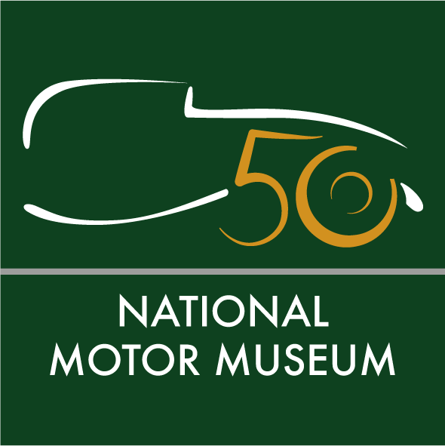
Media news
July 4th, 2022

Celebration of 50th anniversary of the National Motor Museum and unveiling of The Story of Motoring in 50 Objects

Hundreds of cars gathered to celebrate the 50th anniversary of the National Motor Museum at Beaulieu as guests and visitors discovered the final selection to tell The Story of Motoring in 50 Objects.
Owners of Seventies classics joined the party in their Escorts, Minis and Ford Cortinas, as some even dressed for the decade to take part in the 1970s Classic Car Drive-In Day on Sunday 3rd July.
Lord Montagu asked young ambassadors of Starter Motor – the charity which aims to get the next generation driving, maintaining and enjoying classic cars – to choose the best car of the show on his behalf. They chose the Lotus Elan Series 4 SE owned by Beaulieu volunteer Kevin Kinsella, who was called from giving a tour in the National Motor Museum to be presented with his winning trophy. Event-goers picked the People’s Choice award, which was awarded to Wayne Rose for his impressive 1972 Toyota Crown Deluxe.
An anniversary golden paddock recreated the Beaulieu car park of 1972. It also displayed some of the amazing vehicles which took part in the original celebratory cavalcade at the museum opening, half a century ago.
Lord Montagu said: “It’s been quite a trip back in time! When HRH The Duke of Kent came to open Britain’s National Motor Museum in July 1972, it was the proudest moment of my father’s life, and what we have in the museum is his greatest legacy.
“In 1972, our exhibits spanned a period of about 80 years; they now account for over 130 years and so it is no surprise that our collections have expanded considerably, especially in the libraries and archives. It has been with these collections in mind that we’ve created The Story of Motoring in 50 Objects, giving you every reason to re-explore the museum. The exhibition launches the start of our sixth decade and a new chapter in the development of Britain’s National Motor Museum.”
National Motor Museum Trust Chief Executive Jon Murden said: “Our next challenge is to take the museum and its collections forward, by reimagining Edward, Lord Montagu’s vision in order to engage with a wider audience and remain relevant for the future.”
At the celebrations, Lord and Lady Montagu cut a cake which was shaped as one of the #50 objects – the 1930 'Blower' Bentley 4½ litre Supercharged. The Carousels entertained guests with hits from the Seventies, while Friends of the National Motor Museum Trust led their own cavalcade before setting off on a Forest Drive. Meanwhile on the Beaulieu Parkland, the National Austin Seven Rally celebrated a century of one of the world’s best-loved cars.
Final #50objects revealed
Inside the museum, event-goers were the first to see the final selection of the top #50objects in the anniversary display The Story of Motoring in 50 Objects.
The objects were carefully chosen from over 1.7 million items in the internationally-acclaimed collection cared for by the National Motor Museum Trust. Curators whittled down the selection to a shortlist of 150, then made the final choice to include the most historically important vehicles, motoring artefacts, film footage, images, documents and books from its archives.
For pioneering motoring, we had to include the 1903 De Dion Bouton 6hp which started our collection when Edward, Lord Montagu put this car on display in the entrance hall of Palace House as a tribute to his father, the motoring pioneer John Montagu. The 1908 Votes for Women! Shell postcard, linking motoring to female drivers, has also made the final cut.
For achievement and endeavour, the 12hp Daimler is one of the most significant cars in our collection and was the first petrol-engined vehicle to enter the Palace Yard of the House of Commons, after being bought by John Montagu MP in 1899. When he entered the Daimler in the 1,000 Mile Trial ground-breaking drive from London to Edinburgh the following year, it was the first time that many people in Britain had seen a motor car on the road.
The precious 1913 racing silks of Percy Lambert, who was the first man to drive a car more than 100 miles in one hour, have also made the final 50, along with the stunning Land Speed Record breaker Golden Arrow which was chosen for its tremendous aircraft power in a car.
For technology, progress and environment, a 1907 Halda taximeter which gave taxi cabs their name, has also made it into the exhibition, together with a brochure weighing up the options of steam, petrol and electricity during the same year. Cat’s eyes and a crash test dummy have been chosen for helping to make driving safer.
For art, advertising and design, the 1911 Rolls-Royce Spirit of Ecstasy had to make the top 50, as one of the most recognisable sculptures ever made. It was created by Charles Sykes and some of his work was inspired by Eleanor Thornton, the secretary and mistress of John Montagu. The beauty of Lalique’s exquisite glass mascots also put what is believed to be his first work, Cinq Chevaux, amongst our curators’ first choices.
For industry and economy, road builders’ clogs may be less well-known, while a 1920s children’s book telling the story of charabanc rides carrying workers and their families on day trips to the seaside and countryside is a colourful addition to the exhibition. Archive film of the 1913 Ford production line also shows a transformation in industry, marking the start of motoring factory work as we know it.
And finally for society, mobility and leisure, the 1952 DRH car radio provided the first factory-fitted radios in British cars for driving music. In the year of the Queen’s platinum Jubilee, we also had to choose the 1955 Royal Caravan, which is still owned by HRH The Princess Royal who enjoyed touring Buckingham Palace gardens in it, with a young Prince Charles and their father, Caravan Club Patrol HRH Prince Philip the Duke of Edinburgh.
Visit the exhibition

Visitors can discover the full set of 50 objects in the National Motor Museum, as the exhibition remains on display until April 16th, 2023 – using the Smartify app to scan objects and uncover more content and stories.
Explore The Story of Motoring in 50 Objects as part of your ticket on a marvellous day out to Beaulieu that the family can enjoy together. See Bond in Motion – No Time To Die, featuring original cars and gadgets from the latest 007 film, the World of Top Gear and On Screen Cars. Ride on a ‘skytrain’ monorail, have big fun in Little Beaulieu’s adventure play area, experience life ‘upstairs and downstairs’ in Palace House, walk in the footsteps of monks at Beaulieu Abbey, find out about special agents in the Secret Army Exhibition and saunter through the beautiful grounds and gardens. For tickets and details see www.beaulieu.co.uk or call 01590 612345.
See highlights of the 50 objects selection and join the conversation with #50objects on Twitter @Beaulieu_Hants, Facebook at /nationalmotormuseum or Instagram @national_motor_museum
Ends
Note to editors

- For the full set of #50 objects, see the list attached.

- The National Motor Museum is an Accredited Museum and all of its collections have been designated by Arts Council England as being of national and international importance. Inspiration for the museum came from motoring pioneer and transport visionary John 2nd Baron Montagu. His son Edward, Lord Montagu first displayed five cars in the entrance hall of Palace Hall as a tribute to his father, before opening the museum on July 4th, 1972. Together, their legacy resulted in the foundation of the first permanent national motor museum in the world. Edward’s son Ralph is the current Lord Montagu.

Further information from:
Jane Riddiford Ben Coleman
Public Relations PR Executive
Tel: 07818 454513 Tel: 01590 614641
Email: Jane.riddiford@beaulieu.co.uk Email: Ben.coleman@beaulieu.co.uk

Richard Morgan Rachael Goldstraw
Marketing Manager Head of Marketing & Business Development
Tel: 07818 454502 Tel: 07500 882224
Email: Richard.morgan@beaulieu.co.uk Email: Rachael.goldstraw@beaulieu.co.uk

