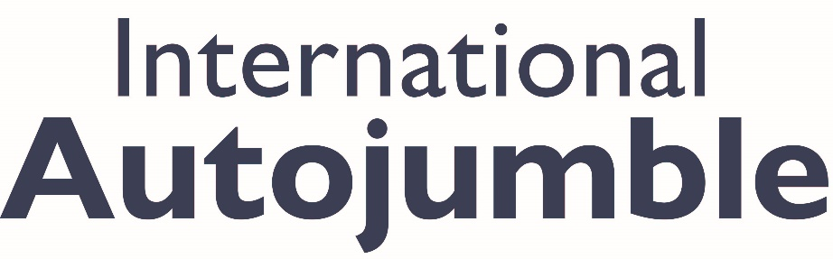
Nifty Fifties display a blast from the past for Beaulieu’s International Autojumble
September 10th & 11th
Beaulieu will be celebrating a golden era of motoring with a brand new Nifty Fifties display, as part of International Autojumble, returning on Saturday 10th and Sunday 11th September for a packed weekend of buying, selling and automotive enjoyment.
Following in the tyre-tracks of the nostalgia-fuelled Forgotten Favourites display at last year’s show, Nifty Fifties will bring together classic vehicles dating from 1950 to 1959, with a crowd-pleasing line-up from this much-loved era. The display will be just one of the features of the event, eagerly anticipated by thousands of motoring enthusiasts.
All 1950s motors are invited to take their places in the show, from popular British saloons and sports cars such as Standards, Wolseleys and Austin-Healeys, to chrome-laded American classics such as Chevrolets and Cadillacs, European favourites such as Porsches, Citroens and Volkswagens, and even eye-catching bubble cars. If your pride and joy was built during that decade, book your place in the line-up now.
To apply to join the Nifty Fifties display with your 1950s car, visit beaulieu.co.uk/events/international-autojumble/nifty-fifties. Places are limited and show entry is free for vehicles that are accepted. Successful owners will receive a pair of weekend entry wristbands for International Autojumble.
Returning to the Beaulieu parkland as the National Motor Museum celebrates its golden anniversary, International Autojumble has been a cornerstone of the event season for over half a century, as the place to search for bargains and great buys. In addition to the huge selection of spare parts on offer for historic vehicles are motoring books, model cars, vintage clothing, signs, collectables, automobilia and all manner of automotive treasures.
The Bonhams auction will return to International Autojumble for 2022. The greatly-anticipated sale will take place on Saturday 10th, with collectors’ cars, motorcycles and automobilia all going under the hammer, while Sunday 11th will see Bonhams experts give informative talks to showgoers on buying and selling at auction.
Automart is the perfect opportunity to sell your classic or vintage car or bike, showcasing it to thousands of potential buyers of the course of the weekend. With a car space also including weekend entry to the show and the whole Beaulieu attraction, it’s a great way to get involved with the big motoring-themed weekend.
For more motors on sale, make sure to look at Dealermart, with top condition classics on offer from traders. While on Sunday Trunk Traders offers the chance to find bargains as enthusiasts sell assorted motoring jumble from their car boots.
Show media sponsor Practical Classics magazine will also be there, as the team talks to showgoers and discusses automotive projects past, present and future.
Advance one-day and two-day visitor tickets are available, with a limited number of premium tickets giving priority parking, fast entry and a complimentary Showguide. For more details and to book your tickets, visit beaulieu.co.uk/events/international-autojumble/tickets. Exhibitors and Trunk Traders can book their stands online at beaulieu.co.uk/events/international-autojumble/exhibitors or contact the events team at events@beaulieu.co.uk or 01590 614614.
Visitor and participant tickets include entrance to all that Beaulieu has to offer. Make sure to explore the National Motor Museum’s new exhibition The Story of Motoring in 50 Objects, and Bond in Motion – No Time To Die, as well as Little Beaulieu, World of Top Gear, On Screen Cars, the ancestral Montagu home Palace House, Secret Army Exhibition, 13th century Beaulieu Abbey and the stunning grounds and gardens. Visit beaulieu.co.uk for more information.

– ENDS –

Further information from:
Ben Coleman Richard Morgan
PR Executive Marketing Manager
E: pr@beaulieu.co.uk E: richard.morgan@beaulieu.co.uk
T: 01590 614641 T: 07818 454502

