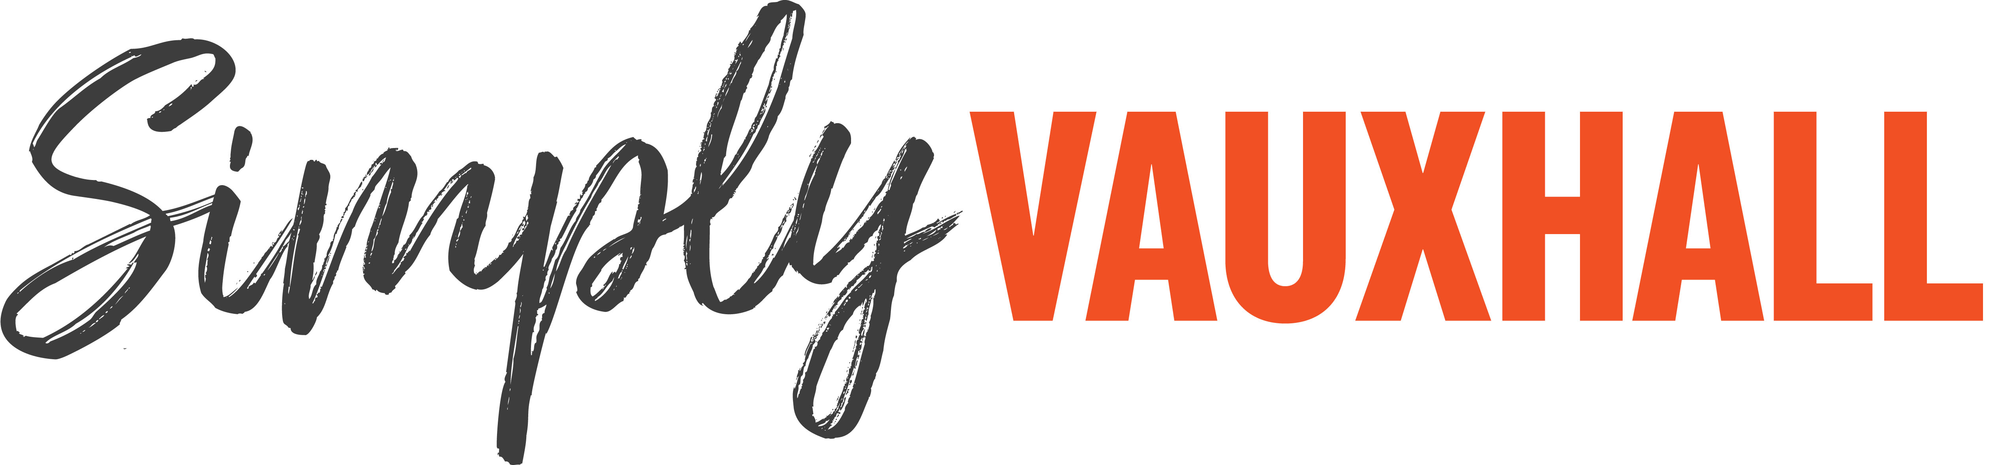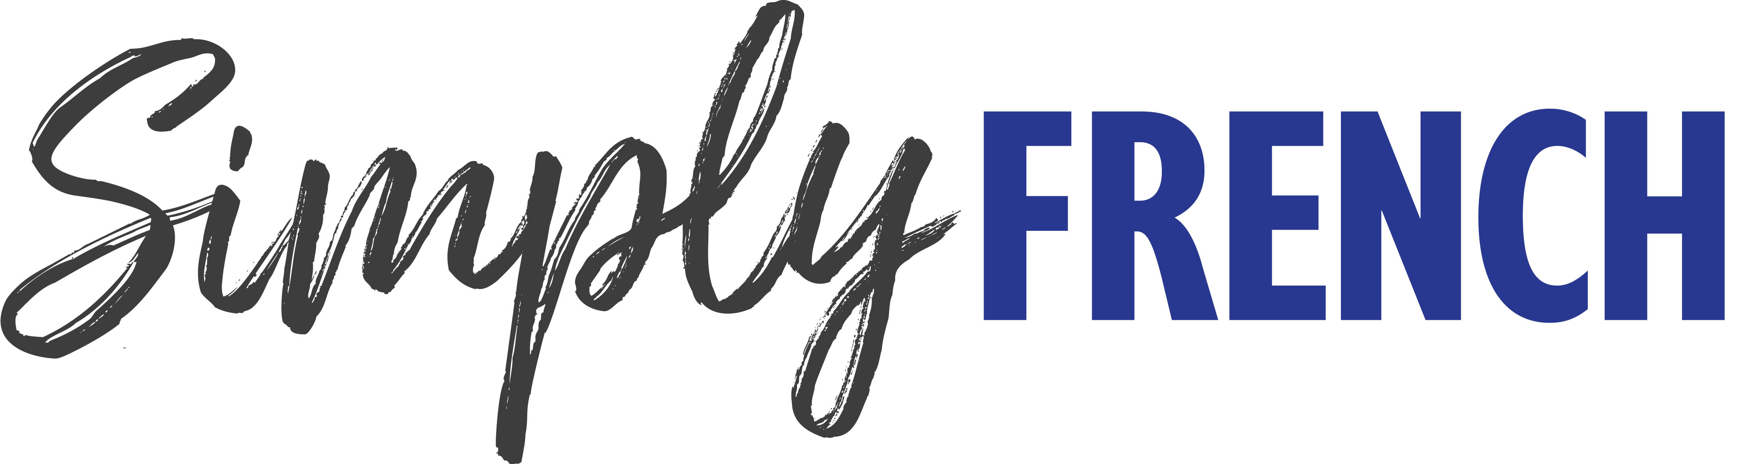
A bumper weekend for super Simply rallies at Beaulieu

Get ready for a bumper motoring-themed weekend at Beaulieu on 16th – 17th July, with two Simply rallies taking place back-to-back, as Simply Vauxhall and Simply French return to the grounds of the National Motor Museum.
Vauxhall fans are in for a treat with Simply Vauxhall on Saturday 16th July, with all cars and vans proudly wearing the famous Vauxhall griffin badge invited to take part in the rally line-up. The show is the perfect opportunity for owners and enthusiasts to catch-up and talk cars.
With Vauxhall owners already booking their places for the must-see rally, the line-up is sure to include a wide variety of Vauxhalls and Opels of all ages. Already booked are Cascadas, Insignias, Zafiras, Astras, Vectras, Adams and Corsas, along with such classics as a 1966 Viva HA SL, a 1990 Carlton, a 1985 Opel Monza GSE, and a 1962 Victor.
Always a calendar highlight with enthusiasts and attraction visitors alike, owing to its impressive variety, Simply French on Sunday 17th July is sure to bring together all manner of colourful and characterful cars originating from the other side of the English Channel. Cars already booked to attend range from a 2021 Alpine A110 and 2010 Renaultsport Megane 250 Cup, to a 1958 Renault 4CV, 1967 Citroen DS Decapotable, 1973 Matra Bagheera and 1984 Talbot 1100 van.
In celebration of 50 years of the much-loved Renault 5, one of France’s best-selling cars, the event will feature Rallye Renault 5, a special display of the various versions of the 5 produced between 1972 and 1996. If you would like to take part with your own 5, head to beaulieu.co.uk/events/simply-french to book.
2022 also marks the 50th anniversary of the National Motor Museum. Opened just in time for the rallies, make sure to see the museum’s brand new exhibition The Story of Motoring in 50 Objects. Amongst the remarkable objects is the French-built 1903 De Dion Bouton Model Q which started the museum collection.
Look out for other French cars on display in the National Motor Museum, including the 1996 Williams Renault FW18, 1986 Citroen 2CV6 Special and 1899 Renault 1¾ hp. While Vauxhall’s proud history is represented by historic examples of the marque, including a legendary 1914 Prince Henry, one of the first true sports cars, and a charming 1939 Ten-Four H-Type. While Bond in Motion – No Time To Die showcases the vehicles and gadgets seen in the latest action-packed Bond film.
At both shows, event-goers can vote for their favourite car of the show in the People’s Choice Award, with the winner receiving a Beaulieu trophy and an Autoglym prize. Voting is open to all visitors until 1pm that day, with the presentation taking place at 2pm.
Participants are encouraged to buy their tickets in advance for Simply Vauxhall at beaulieu.co.uk/events/simply-vauxhall, and can be purchased in advance for Simply French at beaulieu.co.uk/events/simply-french. Participant tickets, for those driving into the show in a qualifying vehicle to join the display, include entrance to the rest of the Beaulieu attraction.
All other visitors should purchase normal visitor admission tickets, which are available to book at beaulieu.co.uk.
Simply Vauxhall and Simply French are just two of the exciting Simply rallies taking place in 2022. Simply Japanese will take place on 24th July, followed by Simply Mercedes on 21st August, Simply BMW on 18th September and Simply British Classics on 25th September. For Beaulieu’s full 2022 event calendar, visit beaulieu.co.uk/events.
Visitor and participant tickets include entrance to all that Beaulieu has to offer, including Bond in Motion – No Time To Die in the National Motor Museum, Little Beaulieu, World of Top Gear, On Screen Cars, the ancestral Montagu home Palace House, Secret Army Exhibition, 13th century Beaulieu Abbey and the stunning grounds and gardens.

– ENDS –

Further information from:
Ben Coleman Richard Morgan
PR Executive Marketing Manager
E: pr@beaulieu.co.uk E: richard.morgan@beaulieu.co.uk
T: 01590 614641 T: 07818 454502

