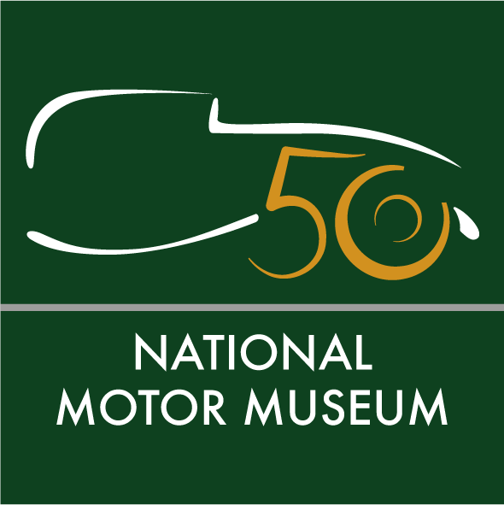

Media news
May 30th 2022

New Classic Grille after-hours events for the
National Motor Museum

The National Motor Museum is throwing open its doors to classic car and motorcycle enthusiasts this summer for three special after-hours events, as it introduces its brand new Classic Grille evenings on 22nd June, 20th July and 24th August, as part of the celebrations of the museum’s 50th anniversary.
Welcoming owners of classic and cherished cars and bikes of all ages, with free admission for attendees, each Classic Grille evening will be an unmissable opportunity for motor fans to drive into the Beaulieu grounds to meet the National Motor Museum curators, witness awesome vehicles from the collections being started up, and chat with fellow enthusiasts while enjoying a tasty bite to eat.
Attendees wishing to enter the National Motor Museum, for a unique after-hours perspective of the cars and motoring objects, can upgrade their ticket on the evening at £10 per adult, children 16 and under go free.
National Motor Museum Trust Chief Executive Dr Jon Murden said: “As part of a range of events to mark the 50th anniversary of the opening of the National Motor Museum in 1972, I’m delighted that we are introducing our new Classic Grille nights.
“The atmosphere inside the Museum is totally different and quite magical in the evening, and we wanted to be able to share that with people in a way that hasn’t been possible before.
“Combined with the potential to take your own classic car or bike on a run to the Museum through the stunning New Forest, something tasty to eat from our BBQ, and witnessing some amazing historic vehicle start-ups, we think Classic Grille will appeal to a wide range of enthusiasts – especially those who’ve maybe never had the chance to visit the National Motor Museum before.”
Take a closer look at fascinating historic motoring objects from the museum’s reserve collections with hands-on ‘Meet the Curator’ sessions, while families can get involved with special activities. Talk to the curatorial and workshop experts who look after more than 1.7 million items and find out more about the work of the National Motor Museum Trust, preserving the nation’s motoring heritage, and its exciting plans for the future.
On Wednesday 22nd June, cruise into the museum grounds in your pride and joy from 6.30pm to park up with other cherished vehicle owners, then experience the heady sights and sounds of the National Motor Museum’s iconic 1930 Bentley 4.5 Litre Supercharged as it growls into life. Take a closer look at a packed display from the team behind the British Motor Show (also at the 24th August event).
Motorbikes will be the stars on Wednesday 20th July, with bike fans in for a real treat that evening. The legendary ex-Mike Hailwood 1961 Honda RC162 will be started up, the impressive sounds of this TT race-winner sure to make the hairs on the back of your neck stand up with excitement. Then see the latest offerings from the two-wheeled world on show with trade stands representing Royal Enfield, Aprilia and Moto Guzzi.
The event on Wednesday 24th August will get the pulse racing, as the colossal 18-litre engine of the 1920 Sunbeam 350hp bursts into action. A century after this incredible racer set its first Land Speed Record of 133.75mph, hear its aero engine roar and get a taste of the pioneering record-breaking era which this car helped to shape.
On each of the evenings, the Brabazon restaurant will be open, along with a ‘Pit Stop BBQ’, with delicious barbeque snacks and hot and cold drinks on offer.
Capacity for the event is limited, so book your free ticket for the evening now at www.beaulieu.co.uk/events/classic-grille-evening, while upgrade tickets for entry for the National Motor Museum, which must be purchased at the event, cost £10 per adult (children are admitted for free). The rest of the Beaulieu attraction will not be open for these events.
Ends

Further information from:
Ben Coleman Richard Morgan
PR Executive Marketing Manager
Tel: 01590 614641 Tel: 07818 454502
Email: pr@beaulieu.co.uk Email: Richard.morgan@beaulieu.co.uk

