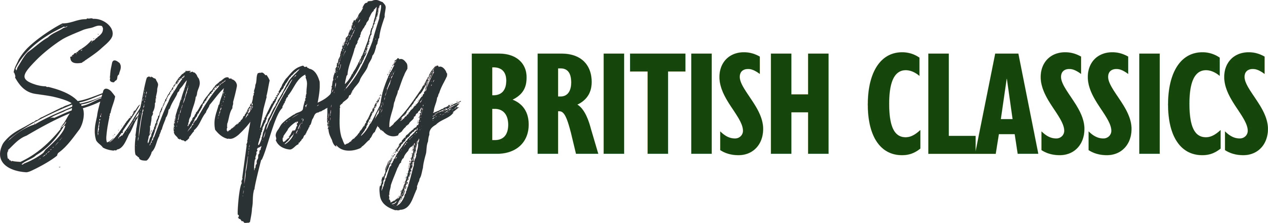

Simply British Classics returns to Beaulieu
Sunday 26th September
Beaulieu is delighted to announce the return of Simply British Classics on Sunday 26th September, with all British classic car owners invited to join the rally in the grounds of the National Motor Museum as part of a superb day out.
Open to any pre-1990 classic vehicle built in Britain, or by a British manufacturer, Simply British Classics got off to a great start in 2020, when a diverse range of classics joined the busy display. This year promises to be just as exciting, with the chance for enthusiasts and families alike to admire an impressive selection of cars on show.
Last year’s event saw an astonishing variety of cars drive in to the Beaulieu parkland. From such rarities as an Allard J2, AC 2-Litre, Buckler special and pre-war Bentley, to much-loved favourites such as Jaguar E-types, Triumph Heralds and Stags, MGBs and Midgets, Minis and Morris Minors, there was something for everyone to enjoy. An Alvis TD21, Armstrong Siddeley Sapphire and Rolls-Royce Silver Shadow rubbed shoulders with a Mini Moke, Standard Vanguard, Bond Bug, Austin Metropolitan, Hillman Minx and many more. This year’s display promises to be equally impressive.
Event-goers can vote for their favourite British classic car of the show in the People’s Choice Award, with the winner receiving a Beaulieu trophy and an Autoglym prize. Voting is open to all visitors until 1pm that day, with the presentation taking place at 2pm.
Once you’ve admired the motors on display out in the showground, make sure to head inside the National Motor Museum. From luxury limousines and Land Speed Record breakers, to racers and familiar family cars of the past, the museum’s collection of over 280 vehicles tells the fascinating story of motoring in Britain.
All tickets must be bought in advance, with carefully-managed capacity limits in place. Rally participants, planning to take part in the show with their British classic car, can book their tickets with confidence thanks to Beaulieu’s Covid-19 refund policy*. Visit www.beaulieu.co.uk/events/simply-british-classics for further details and to buy your participant tickets.
All other visitors should purchase normal visitor admission tickets, which are available to book at www.beaulieu.co.uk.
With plenty for all the family to do together at Beaulieu, Simply British Classics is just one of the exciting Simply rallies taking place in 2021, with Simply Smart set to follow on Sunday 7th November.
Visitor and participant tickets include entrance to all that Beaulieu has to offer, including the National Motor Museum, Little Beaulieu, On Screen Cars, the ancestral Montagu home Palace House, Secret Army exhibition, 13th century Beaulieu Abbey and the stunning grounds and gardens. Visit www.beaulieu.co.uk for more information.
* Book with confidence, knowing that we've got you covered with our Covid-19 refund policy. If the event is unable to take place due to Government guidance, we will happily transfer your ticket to a future event or issue you with a full refund.

– ENDS –

Further information from:
Ben Wanklyn Richard Morgan
PR Executive Marketing Manager
E: pr@beaulieu.co.uk E: richard.morgan@beaulieu.co.uk
T: 01590 614641 T: 07818 454502

