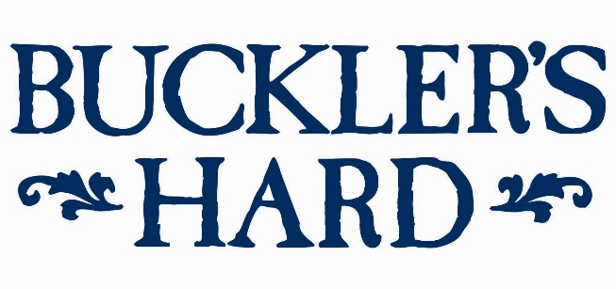
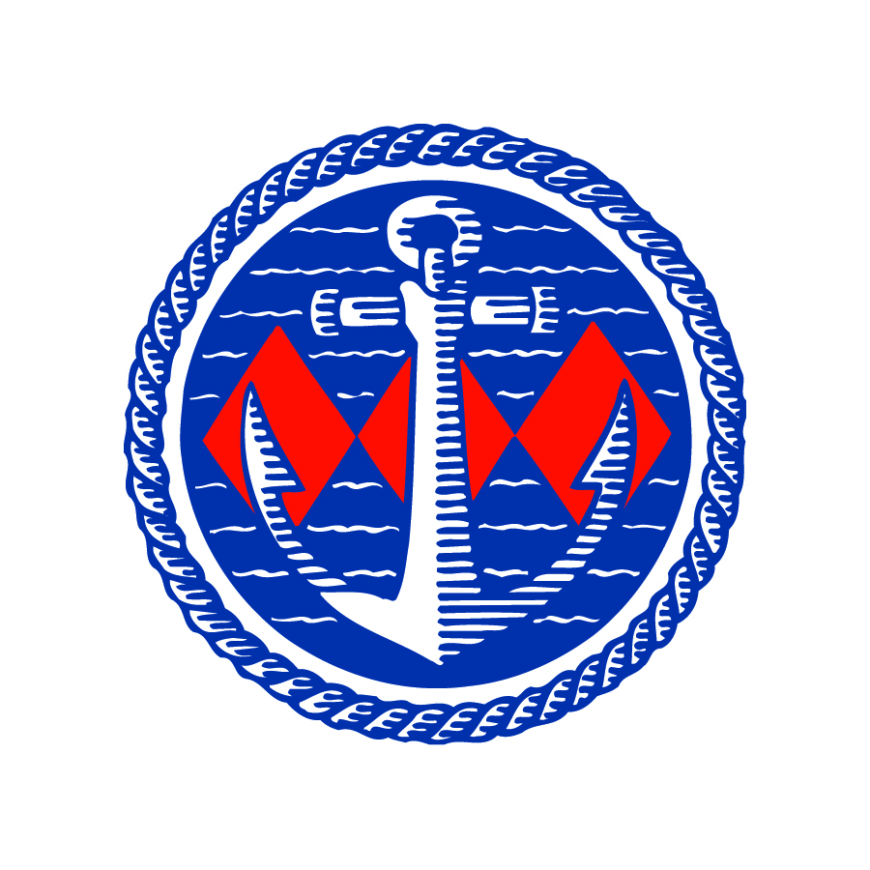

Theresa May sails on the Beaulieu River to visit Buckler’s Hard
Former Prime Minister Theresa May made the most of her new-found leisure time with a sail along the picturesque Beaulieu River and a visit to Buckler’s Hard over the bank holiday weekend.
Following her recent resignation, the Rt Hon Theresa May MP has more time to indulge in her own pastimes and arrived in style on a Sunseeker yacht which moored at the bottom of Buckler’s Hard High Street late Saturday afternoon.
Mrs May and her husband Philip enjoyed afternoon tea on deck, overlooking the unspoilt haven of the Beaulieu River, before being given a personal tour of the once thriving shipbuilding village where ships for Nelson’s fleet at Trafalgar were built in the 18th century.
The Hon Mrs Mary Montagu-Scott, who is the sister of Lord Montagu, Director of the Maritime Museum and Commodore of the Beaulieu River Sailing Club, gave a guided tour around the Maritime Museum and the rest of the village to tell Buckler’s Hard’s remarkable story.
She said: “It was a pleasure to share our passion for Buckler’s Hard and the Beaulieu River and the story of its fascinating past. This is a very special place and we were honoured that they chose to make a personal visit.
“Mr and Mrs May were both particularly interested in British history and had recently been reading about the role that Buckler’s Hard played during WWII. They have both said that they thoroughly enjoyed their time here and their visit to the Maritime Museum.”
Mr and Mrs May’s tour also included exploring the Shipwright’s Cottage and Chapel of St Mary’s, with its smugglers’ cellar beside the altar. End-of-summer visitors to Buckler’s Hard can enjoy the same features, see living history characters bringing its past to life until September 1st and trips on the River Cruise until September 22nd. Refreshments are available in the Captain’s Cabin Tea Rooms. For tickets and details see www.bucklershard.co.uk or call 01590 616203.
The Beaulieu River is one of the few privately owned rivers in the world and the custodianship of the Montagu family over four centuries has kept its unique character and natural charm, making it one of the most picturesque locations on the south coast and a popular boating destination close to the sailing centres of Cowes, Lymington and Hamble. For information about moorings and visits see www.beaulieu.river.co.uk or call the Buckler’s Hard Yacht Harbour team on 01590 616200.
--- ENDS ---
For press enquiries, please contact:
Jane Riddiford Ben Wanklyn
Public Relations Manager Public Relations Executive
T: 01590 614603 T: 01590 614641
E: pr@beaulieu.co.uk E: ben.wanklyn@beaulieu.co.uk

