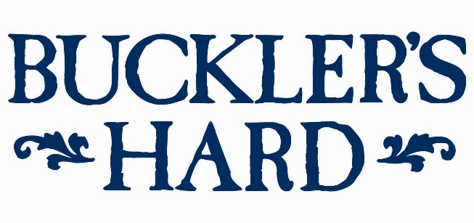

Model boats D-Day re-enactment for May half-term at Buckler’s Hard
For an action-packed start to May half-term, see a model boat re-enactment of the Normandy landings on the Beaulieu River at the historic shipbuilding village of Buckler’s Hard.
Marking the 75th anniversary of the D-Day landings and the important role played by Buckler’s Hard during WWII, Portsmouth Model Boat Display Team will perform its unique display with pyrotechnics, remote control scaled-down boats and miniature tanks on Saturday 25th and Sunday 26th.
At 2.30pm on both days, see corvette warships and merchant navy vessels dodge explosions on the water, as landing craft deliver model tanks to the shore to storm a 45 square foot replica of a Normandy village. Listen to commentary as the historic events unfold throughout the 30-minute display.
Model sections of Mulberry harbour will be built at Buckler’s Hard, as part of the display. The temporary floating structures were essential for offloading vital supplies on Normandy beaches during the D-Day campaign.
Also on both days, step on board real-life harbour defence motor launch HMS Medusa which helped to clear the way to Omaha Beach for D-Day. Meet the crew on board and learn more about the vessel’s role in history and its more recent part in filming for Kenneth Branagh’s Dunkirk movie, taking soldiers including One Direction’s Harry Styles out to a destroyer.
Buckler’s Hard visitors will be able to take tours on board HMS Medusa from 10am - 1pm and 2-5pm on Saturday 25th, and 10am - 1pm and 2-4pm on Sunday 26th. Voluntary donations to The Medusa Trust will be gratefully received.
Throughout May half-term (May 25th - June 2nd) step back in time and chat to living history characters in the village to discover what life was life like during its shipbuilding heyday.
Follow the fun family quiz trail around the Maritime Museum to learn more about the Buckler’s Hard story. See displays in the labourers’ and shipwrights’ cottages, the smugglers’ cellar beside the altar in the Chapel of St Mary’s and leave time for a visit to the Captain’s Cabin Tea Rooms.
Take a trip on the River Cruise to explore the rich history and wildlife of the Beaulieu River. Listen to the captain’s commentary about the fascinating history of the unspoilt haven and the creatures that inhabit its riverbanks. For more details on this separately charged cruise see www.bucklershard.co.uk/attractions/river-cruise.
All other features are included in a ticket to Buckler’s Hard. Tickets can be bought in advance online. Annual passes are also available and offer unlimited visits to Buckler’s Hard and 10% discount on gift purchases from the Maritime Museum shop. For tickets and details see www.bucklershard.co.uk or call 01590 616203.
--- ENDS ---

For press enquiries, please contact:
Jane Riddiford Ben Wanklyn
Public Relations Manager Public Relations Executive
T: 01590 614603 T: 01590 614641
E: pr@beaulieu.co.uk E: ben.wanklyn@beaulieu.co.uk

