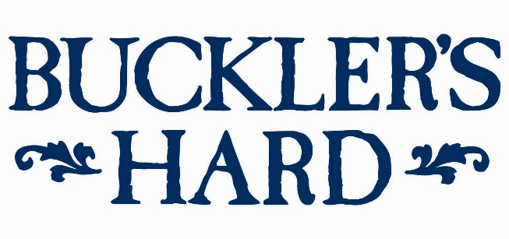

Shipwrightry and Morris dancing for May bank holiday
at Buckler’s Hard

Traditional skills and customs will come to life at Buckler’s Hard this May bank holiday with shipwrightry demonstrations and Morris dancing in the historic shipbuilding village from May 4th - 6th.
Over the weekend, watch students in the Shipwright School as they learn traditional woodworking and ancient shipbuilding techniques that would have been used at Buckler’s Hard when ships for Nelson’s Trafalgar fleet were built there in the 18th and 19th centuries. Be transported back in time to its shipbuilding heyday by the smell of sawdust and sounds of sawing, as they transform oak timbers from the Beaulieu Estate.
Then on Saturday May 4th celebrate one of the most vibrant aspects of life in a bygone age, with Morris dancing in the village street. See the Deorfrith Morris and Moonshine Border Morris dancers perform for an hour from 11.15am, as they celebrate an ancient custom that dates back centuries.
To continue your step back in time, discover what life was like at Buckler’s Hard with a fun family quiz trail and visit to the Maritime Museum. See displays in the labourers’ and shipwrights’ cottages and the smugglers’ cellar beside the altar in the Chapel of St Mary’s, then leave time for refreshments at the Captain’s Cabin Tea Rooms.
Take a trip on the River Cruise to explore the rich history and wildlife of the Beaulieu River. Listen to the captain’s commentary about the fascinating history of the unspoilt haven and the creatures that inhabit its riverbanks. For more details on this separately charged cruise see www.bucklershard.co.uk/attractions/river-cruise.
All other features are included in a ticket to Buckler’s Hard. Tickets can be bought in advance online. Annual passes are also available and offer unlimited visits to Buckler’s Hard and 10% discount on gift purchases from the Maritime Museum shop. For tickets and details see www.bucklershard.co.uk or call 01590 616203.
--- ENDS ---
For press enquiries, please contact:
Jane Riddiford Ben Wanklyn
Public Relations Manager Public Relations Executive
T: 01590 614603 T: 01590 614641
E: pr@beaulieu.co.uk E: ben.wanklyn@beaulieu.co.uk

