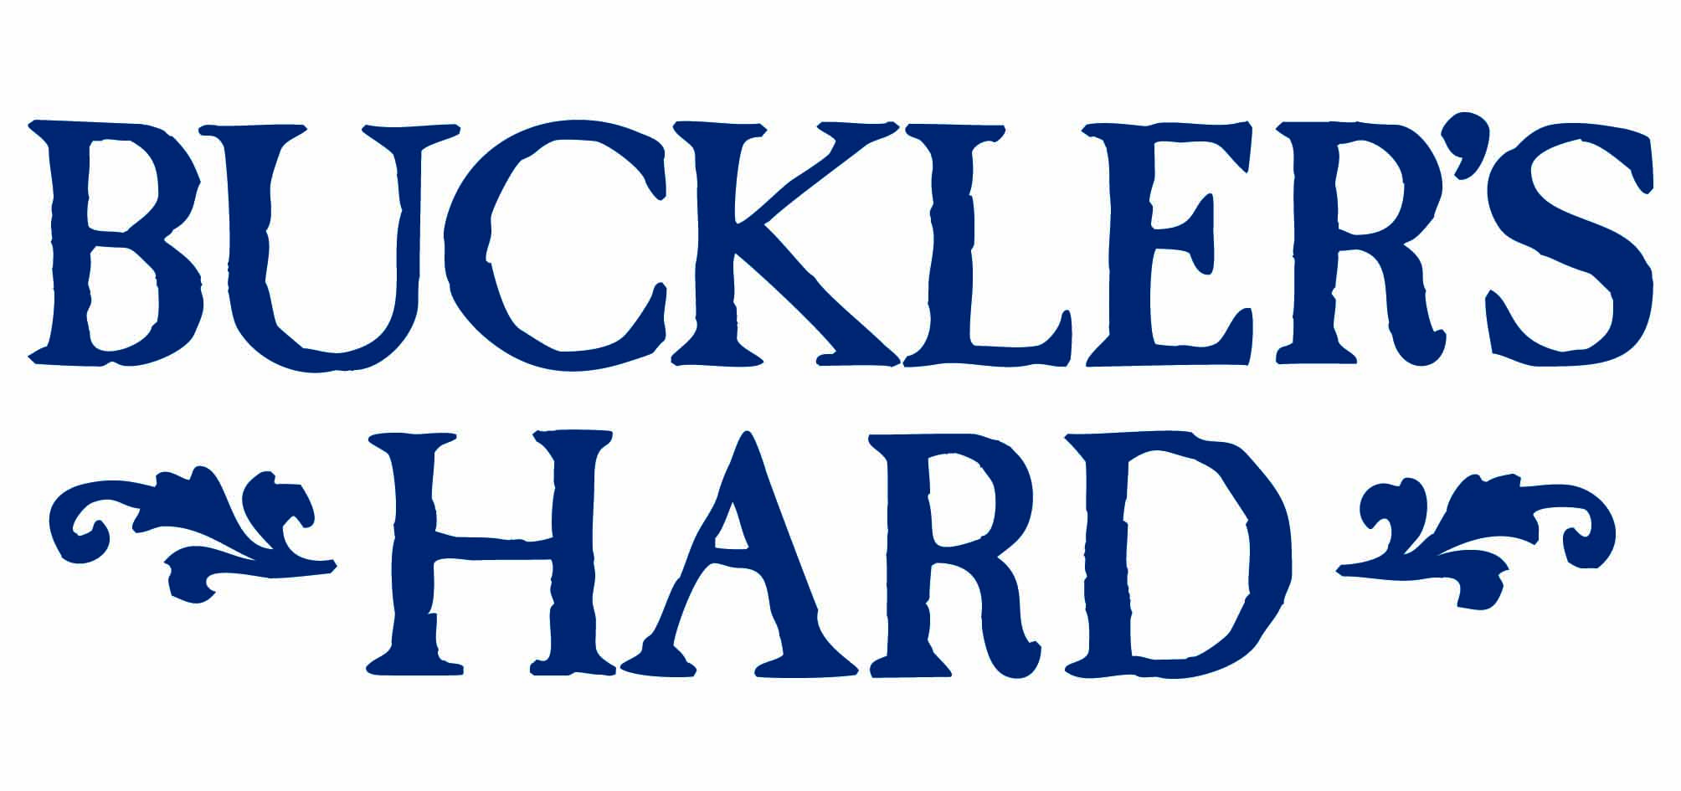
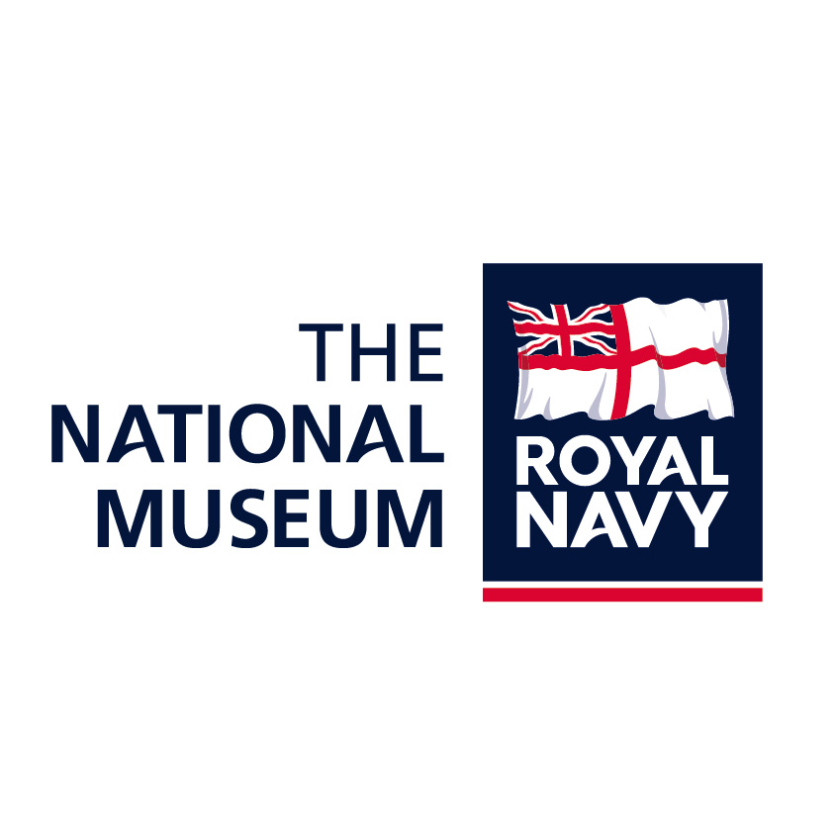
11 June 2018

Buckler’s Hard Maritime Museum becomes an affiliate of The National Museum of the Royal Navy at ceremony on HMS Medusa

They have a shared history at the heart of the country’s proud shipbuilding and navy story and now Buckler’s Hard Maritime Museum has been formally welcomed to The National Museum of the Royal Navy’s affiliate partnership scheme.

The official partnership was marked at a ceremony onboard D-Day veteran HMS Medusa at Buckler’s Hard. Medusa, a harbour defence motor launch, saw service on D-Day in 1944 and is another affiliate member of The National Museum. She was visiting Buckler’s Hard for the Whitsun Bank Holiday.

Buckler’s Hard Maritime Museum Director Mary Montagu-Scott said: “We are delighted to be strengthening our ties with the National Museum of the Royal Navy. Many ships were built on contract for the Royal Navy at Buckler’s Hard – including the 64-gun Agamemnon in 1780, 36-gun Euryalus in 1803 and 74-gun Swiftsure in 1804 – and we continue to share that story with visitors to the Maritime Museum.”

Director of Partnerships, The National Museum of the Royal Navy, Commander Tim Ash said: “We are delighted that the Buckler’s Hard Maritime Museum has become an affiliate. It will strengthen understanding between our work, and we look forward to developing new stories together on the people that built the Royal Navy’s ship’s and our relationship with the New Forest.”

Alan Watson, Commanding Officer of HMS Medusa said: “As an affiliate of the museum, we see the very real benefits of being part of the wider network and we’re delighted to be able to witness this partnership today.”

Historically, Buckler’s Hard on the banks of the Beaulieu River was a crucial shipbuilding centre for the Royal Navy, most notably for Vice-Admiral Lord Nelson’s favourite ship HMS Agamemnon using timber from the New Forest. The river also had a major role in preparations for D-Day.

The expanding affiliation scheme brings together independent museums and organisations that have important naval heritage. Affiliation links the museum heritage to better explain the British naval story and to also share visitor activities, teach new skills and promote work together.

--- ENDS ---

About The National Museum of the Royal Navy

- The National Museum of the Royal Navy was established following the amalgamation of the Royal Navy’s Fleet Air Arm, Royal Marines, Submarine and Royal Navy Museums, with headquarters in Portsmouth Historic Dockyard. It has since expanded with museums in Gosport, Hartlepool, Belfast and Devonport. It owns 11 ships including HM Submarine Alliance, HMS Caroline, HMS Trincomalee, HMS Victory and HMS Warrior.

- The affiliate members scheme currently has seven other members in addition to HMS Medusa: The Coastal Forces Heritage Trust (Gosport), HMS Unicorn (Dundee), The Haslar Heritage Group (Gosport), HMS Courageous (Devonport), HQS Wellington (London), the D-Day Story (Portsmouth) and the Maritime Museum in Malta. The scheme continues to expand.

About Buckler’s Hard

- Visitors to the unspoilt haven of Buckler’s Hard can step back in time to its shipbuilding heritage at the village where ships for Nelson’s fleet at Trafalgar were built. The Maritime Museum brings its history to life through characters such as Henry Adams, the Master Shipbuilder at Buckler’s Hard between 1744 and 1805. Visit the labourers’ and shipwrights’ cottages and the Chapel of St Mary’s, with a viewing window beside the altar revealing a cellar which was probably used as a store for smuggled goods.

- Buckler’s Hard also played an important role during World War II and visitors can step on board HMS Medusa later in the year during October half-term, to learn more about its role helping to clear the way to Omaha Beach for D-Day. The harbour defence motor launch can be seen in the recently released Dunkirk movie taking soldiers including One Direction’s Harry Styles out to a destroyer. To learn more about the Beaulieu River, take a relaxed River Cruise and enjoy the commentary. For tickets or more information see www.bucklershard.co.uk or call 01590 616203.

For press enquiries, please contact:

Jane Riddiford Ben Wanklyn
Public Relations Manager Public Relations Executive
T: 01590 614603 T: 01590 614641
E: pr@beaulieu.co.uk E: ben.wanklyn@beaulieu.co.uk

