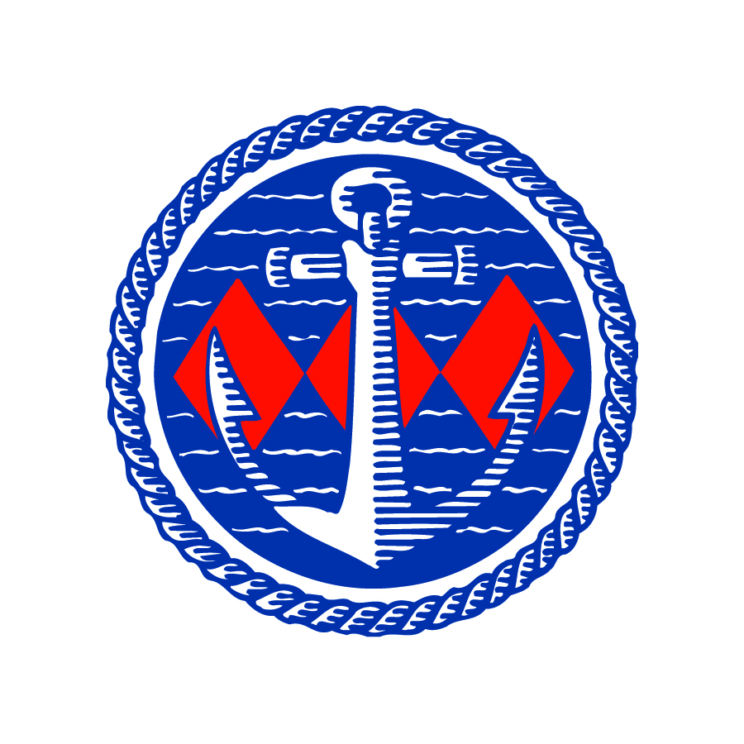

Explore ashore with bike hire at Buckler’s Hard Yacht Harbour

Buckler’s Hard Yacht Harbour is helping sailors to unlock the delights of the New Forest by taking to two wheels, with the chance to hire bikes and explore one of the south coast’s most picturesque locations.
Renowned for its untouched natural beauty, the Beaulieu River is the perfect place for any mooring holder or visiting sailor to start their biking adventure and see for themselves the historic towns, great pubs, restaurants and stunning scenery that is all within easy reach.
Introduced in time for the summer season, adult and child bikes are available for hire, meaning that the whole family can go along for a ride and make the most of their time in the New Forest. The bike hire is in partnership with New Forest Activities and each cycle comes equipped with a helmet for its rider, bike locks, puncture repair kits and maps of the area for easy navigation.
Harbour Master Wendy Stowe said: “Being able to offer bike hire for the first time is a real benefit to visitors and mooring holders, meaning that their trip doesn’t have to stop when they tie up their boat. No matter if they want a gentle ride to Beaulieu or an energetic jaunt to Brockenhurst, Lymington or even further afield, this is a terrific way to see more of the area. The initiative is part of our ongoing investment in services and facilities to ensure the Beaulieu River keeps its reputation as a favourite destination.”
To book bikes in advance of a visit and for information about berths, contact the Harbour Master’s Office at harbour.office@beaulieu.co.uk or 01590 616200.
The new service is the latest in a series of investments to improve and update services and facilities, which have included the recent opening of a £400,000 luxury showers and facilities building.
The Beaulieu River is one of the few privately-owned rivers in the world which has ensured it remains an unspoilt haven in the heart of the New Forest National Park, while keeping pace with modern demands. The popular boating destination is one of the most picturesque locations on the south coast, close to the sailing centres of Cowes, Lymington and Hamble.

For more details see www.beaulieuriver.co.uk and follow the latest news on Facebook /beaulieuriver and Twitter @BeaulieuRiver.

-ENDS-
Further information from:

Jane Riddiford Ben Wanklyn
Public Relations Manager PR Executive
Tel: 01590 614603 Tel: 01590 614641
E: pr@beaulieu.co.uk E: ben.wanklyn@beaulieu.co.uk

