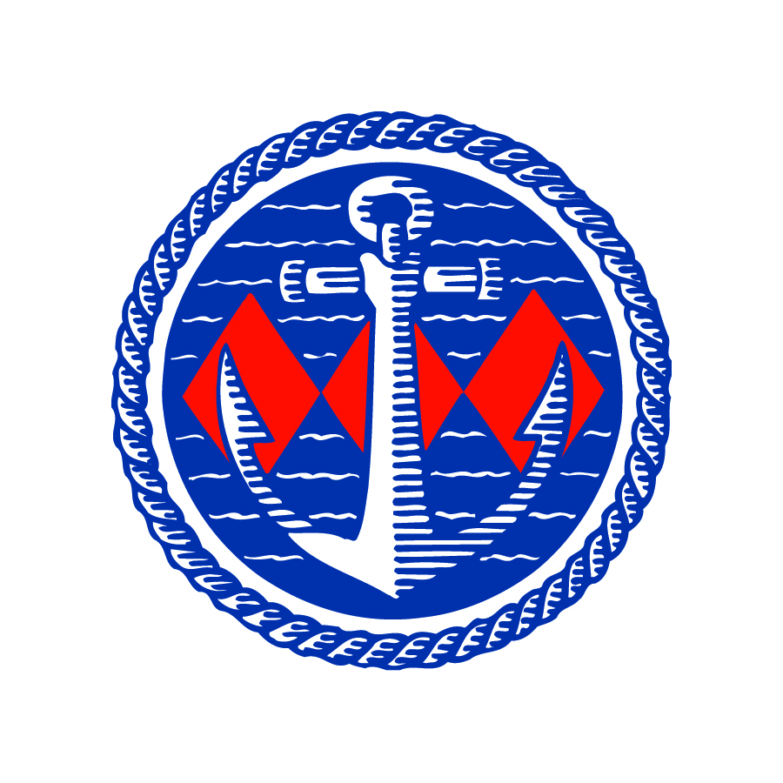

World race winner opens new facilities at Buckler’s Hard Yacht Harbour on Beaulieu River

Round the World race winner Mike Golding OBE has opened new five-star facilities after a £400,000 investment at the Beaulieu River Buckler’s Hard Yacht Harbour.
To welcome sailors for the start of the season, the upgraded showers and facilities building was opened on March 24th and will offer mooring holders and visitors first-class services in keeping with the yacht harbour’s natural setting in the New Forest National Park.
The project has been overseen by Lord Montagu and his sister, the Hon Mrs Mary Montagu-Scott – who is High Sheriff of Hampshire and a keen sailor and interior designer. She has taken inspiration for the décor of the 11 large, luxury rooms from their New Forest surroundings.
Heavy oak doors, portholes bearing the Beaulieu River emblem, underfloor heating and luxury fittings complete the contemporary interior. A cosy seating area to warm up after a chilly sea voyage is also complemented by artwork from entrants to the annual Beaulieu River photographic competition.
Lord Montagu and Mary, who is also Commodore of the Beaulieu River Sailing Club, joined world champion and global record breaker Mike Golding to welcome mooring holders for the opening. A raffle also raised more than £200 in support of the Jubilee Sailing Trust.
Mike Golding said: “When we were training Round the World race crews, we stopped at all of the marinas in the Solent area and always judged the venue by the quality of the facilities – and these at the Beaulieu River are outstanding.”
Mary Montagu-Scott said: “This is part of a programme of investments in the Beaulieu River, with a new approach for modern times. We have been delighted to open the new facilities for moorings holders and visitors.”
The building includes a fully-equipped laundrette to refresh clothing and linen after days or weeks afloat, as well facilities for families and disabled visitors. It is the latest in a series of investments in the five Gold Anchors-winning Buckler’s Hard Yacht Harbour on the unspoilt Beaulieu River – which is one of the few privately owned estuaries in the world.
The Beaulieu River’s unique character and natural charm make it a popular boating destination considered to be one of the most picturesque locations on the south coast and close to the sailing centres of Cowes, Lymington and Hamble.
Free Wi-Fi, an on-site chandlery open seven days a week and cycle hire are available at Buckler’s Hard Yacht Harbour. A restaurant, bar and tea shop are on the doorstep at the 18th century shipbuilding village of Buckler’s Hard, with its Maritime Museum.
For more details see www.beaulieuriver.co.uk and follow the latest news on Facebook /beaulieuriver and Twitter @BeaulieuRiver.

-ENDS-
Further information from:

Jane Riddiford Ben Wanklyn
Public Relations Manager PR Executive
Tel: 01590 614603 Tel: 01590 614641
E: pr@beaulieu.co.uk E: ben.wanklyn@beaulieu.co.uk

