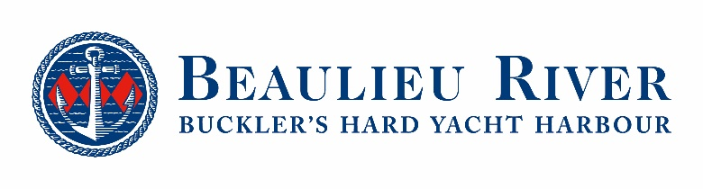
Media news
August 24th 2020

Design a burgee for 50 years of Buckler’s Hard Yacht Harbour
Get creative and help Buckler’s Hard Yacht Harbour to celebrate its half century in style, by designing a special golden anniversary burgee to mark the occasion.
2021 will mark the 50th anniversary of the founding of the marina on the picturesque banks of the Beaulieu River and as part of the celebrations, a limited edition burgee will be given to all resident mooring holders to proudly display on their boats – and you will have the chance to design this historic flag.
No matter if you are a keen sailor, a budding artist, or simply in love with this stunning south coast location, why not create the perfect design to mark the occasion. Will your entry be selected to be immortalised as the Buckler’s Hard Yacht Harbour anniversary burgee?
Let your creativity run wild! With so many different burgees to be seen flying from the rigging of yachts on the Solent, there are plenty to be inspired by. Perhaps your design will incorporate the Buckler’s Hard Yacht Harbour logo, give a nod to its golden anniversary, or reflect the colours, history or wildlife of the Beaulieu River?
Send your designs to competitions@beaulieu.co.uk by 30th October 2020, extended from the original deadline, to be in with a chance of being selected. Visit www.beaulieuriver.co.uk/anniversary-burgee for more information and for full terms and conditions.
The award-winning yacht harbour is currently undergoing a £2m reconfiguration to provide more convenient walk-ashore moorings, bigger berths and improved facilities, while keeping the character which makes it so special. The first phase of the redevelopment is complete and reservations are being taken for the increased capacity, with bookings also being taken for a further release of larger berths which will be provided by the second phase of work in March 2021. To reserve a berth or for more details see www.beaulieuriver.co.uk, email harbour.office@beaulieu.co.uk or call 01590 616200.
The gem of the Solent, at the gateway to the New Forest National Park, has a long track record of giving a personal and outstanding service to its customers. Full marina services, an open policy boatyard and chandlery are offered, along with a range of benefits including free Wi-Fi. A restaurant, bar and tea shop are on the doorstep at Buckler’s Hard, while its Maritime Museum tells the story of the shipbuilding village where Nelson built ships for his fleet at Trafalgar during the 18th and 19th centuries.
Ends

Further information from:

Rachael Goldstraw Lindsay Harris
Head of Marketing & Business Development Senior Marketing Executive
Email: rachael.goldstraw@beaulieu.co.uk Email: lindsay.harris@beaulieu.co.uk
Tel: 07500 882224 Tel: 07919 543726

