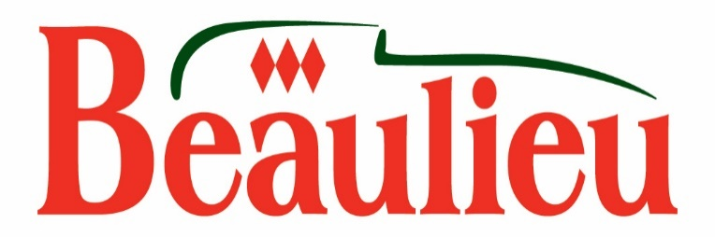

Lord Montagu chooses name for the green man

Lord Montagu has had fun choosing the name for the green man tree carving from more than 70 suggestions by Beaulieu visitors.

The characterful sculpture, which has been carved from a live oak on the bank of the attraction’s Mill Pond Walk, will be called Quirky Quercus.

Lord Montagu said: “It wasn’t easy. I went to the green man and read the list of names to him. He listened attentively, but remained expressionless. He was evidently giving the matter much careful thought. I ran through the list again, pointing out some of my favourites: Sir Ligneous, Bloak and Edwood, but it was only when I got to Quirky Quercus that his green hair started waving about and I knew that this was the one.

“Encouraged by this, I mischievously suggested that Donald Trunk might be fun, but he fell silent again. I knew what he was thinking: ‘I’ve already been here for a couple of centuries and I’m not finished yet – Presidents come and go every few years’. Thank you to Tianna Garland for her excellent suggestion. Some of the other names will remain on file for possible future tree carvings. Quirky Quercus won’t be on his own for long.”

Visitors shared their suggestions for the green man’s name via Beaulieu’s Facebook, Twitter and Instagram throughout the summer. Competition winner Tianna Garland, from North Baddesley, Southampton, chose the winning name.

Tianna said: “It’s brilliant news. I am fairly local to Beaulieu and have visited many times over the years. I saw the picture of the tree and immediately thought how lovely and quirky it was. I realised it was formed from oak and the name just sprang to mind. I think that it is an amazing carving and will use my competition prize of a family pass to bring my daughter’s young family to see it in the Mill Pond setting.”

The characterful green man, which has been carved from a live oak and uses the tree’s green leaves as his hat, is one of three stunning carvings which have recently brought to life ancient mythical creatures.

Skilfully carved by expert wood carver Paul Sivell using old oak trees rooted in the grounds of the Montagu ancestral family home Palace House, these incredible sculptures could have stepped out of the pages of a story book.

The green man sculpture perfectly represents this ancient character from folklore who traditionally tends to new life in the forest, watching over the plants and animals. His painstakingly sculpted face and beard are complimented by the walking stick in his hand, while he supports a wooden squirrel, black and white woodpecker and red-breasted robin.

As part of the set of new tree sculptures, a tree-top griffin marks the start of the Mill Pond Walk and welcomes visitors to Beaulieu near the entrance to the attraction. The magnificent beast – with the wings, head and talons of an eagle and the body, tail and legs of a lion – is the heraldic creature which supports the Montagu family’s coat of arms. Visitors riding on the Monorail have a high-level view of this remarkable sculpture.

Stretching out across the Mill Pond is another new carving – a many-headed serpent. The sprawling limbs of this oak formed the perfect shape to create a serpent slithering out into the water.

The magic continues along the Mill Pond Walk with tiny fairy doors which have been hidden in the trees. Why not enter the realms of magic in your search for these entrances to the Beaulieu Estate’s tiniest homes . . . what magical creatures might be living behind each of the miniature door creations?

The tree carvings and fairy doors are included in the general admission to Beaulieu along with entry to the National Motor Museum and its collection of more than 250 vehicles, the new-look World of Top Gear, On Screen Cars, Beaulieu Abbey, Palace House and the picturesque grounds and gardens. For advance tickets see www.beaulieu.co.uk or call 01590 612345 for more details.

--ENDS--

Further information from:

Jane Riddiford Ben Wanklyn
Public Relations Manager PR Executive
Tel: 01590 614603 Tel: 01590 614641
E: pr@beaulieu.co.uk E: ben.wanklyn@beaulieu.co.uk

