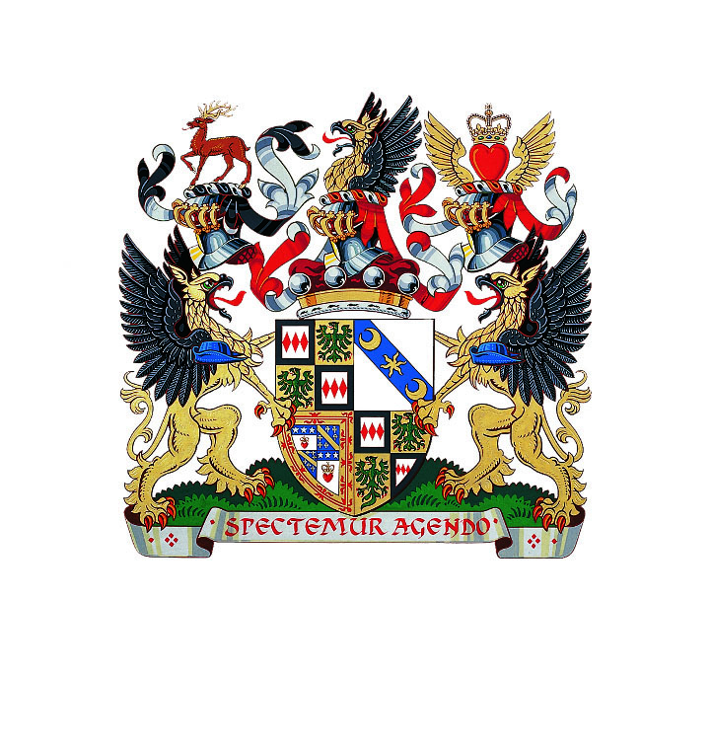
It is with deep sadness that we announce the death of Edward, 3rd Baron Montagu of Beaulieu. He died peacefully at his home on 31st August 2015, aged 88, after a short illness. He is survived by his wife Fiona, his son and heir Ralph, daughter Mary and second son Jonathan. In accordance with his wishes, the estate and visitor attractions are continuing to operate as usual. An estate funeral will be held at Beaulieu, followed by a memorial service at St Margaret’s, Westminster for his friends in London and further afield. The dates of these to be advised.

All enquiries to:

Beaulieu Press Office: Polymedia PR
Margaret Rowles Jane Riddiford
Tel: 01590 614603 Tel: 01329 822866
(m) 07881782369 (m) 07826 916092
E: pr@beaulieu.co.uk E: janeriddiford@polymediapr.co.uk

Ben Wanklyn
Tel: 01590 614641
(m) 07900 264393
E: ben.wanklyn@beaulieu.co.uk

