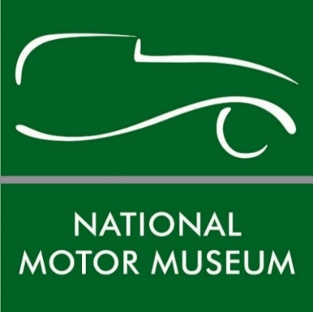
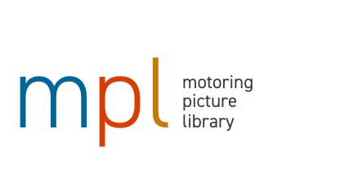

Beaulieu’s Motoring Picture Library opens digital doors to one of the world’s largest collections

The Motoring Picture Library at the home of the National Motor Museum at Beaulieu has opened its digital doors to one of the largest motoring picture collections in the world. A new improved website is making access easier to over a million historic motoring images which span from the 1880s to the present day.
MPL has over 120,000 colour images and nearly a million black and white photographs filed and catalogued, with thousands of digital originals. Its subject matter includes cars, motorcycles and commercial vehicles, covering the motor industry, motor sport, the social history of motoring and a huge range of motoring and motor sport personalities. It also includes spectacular motoring art in the form of sales brochures, posters and paintings.
Celebrated highlights include the Bill Brunell collection, depicting motorsport and social history from the Twenties and Thirties, and the specialist Formula 1 photography of the Fifties and Sixties by Maxwell Boyd.
Since it was established over 50 years ago by Edward, Lord Montagu, the library has grown to become one of the most comprehensive sources of motoring photographs, supplying pictures globally to enthusiasts as well as for commercial ventures, publishing, broadcast and advertising industries.
Picture Library Manager Jon Day: “The aim of MPL is to offer a fast, efficient and competitive service to every user, whether they be a major publisher or advertising agency, a public service, broadcaster, car club or motoring enthusiast. In every case, we are here to make sure you have the best chance of finding what you are looking for.”
MPL also has nearly a million further motoring images which are still to be digitised, so welcomes calls to source specific images. Picture researchers are welcome to visit in person, by prior appointment.
A fully equipped drive-in studio is also offered in the grounds of the National Motor Museum, which is available to hire for photographic shoots.

A Film Library was also established in 1979, with an initial aim to collect and conserve film on all aspects of motoring for future generations. The film library includes private collections – including those of Ford, Vauxhall, the Rootes Group, Metropolitan Police, the AA and Dunlop – and now comprises of nearly 40,000 items. It has installed its own broadcast standard telecine facility for transferring film to video in-house, as well as a High Definition Spirit telecine to transfer film to full HD. For details contact filmandvideo@beaulieu.co.uk.
The picture library is just one element of the National Motor Museum Trust’s work to preserve motoring history. The museum’s collection of over 280 vehicles is world-famous, along with its extensive range of motoring artefacts and specialist reference library. For more information about the Motoring Picture Library see www.motoringpicturelibrary.com or contact Jon Day at jon.day@beaulieu.co.uk or on 01590 614656.
--ENDS--

Further information from:

Jane Riddiford Ben Wanklyn
Public Relations Manager PR Executive
Tel: 01590 614603 Tel: 01590 614641
E: pr@beaulieu.co.uk E: ben.wanklyn@beaulieu.co.uk

