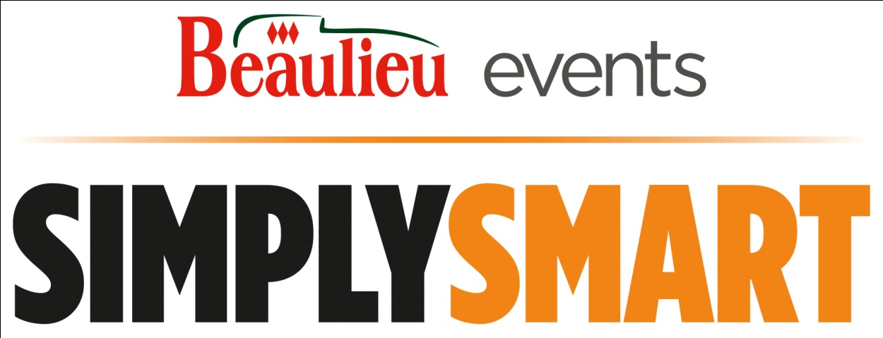
8th November 2015
Simply Smart, Beaulieu’s celebration of the compact and characterful Smart car, will return on Sunday 8th November 2015. All ages and models of Smart car are welcome to join the display in the grounds of the National Motor Museum, which promises to once again showcase the wide variety of bright colour schemes favoured by Smart owners.
Events Co-ordinator Charlotte Mountain said: “We are really looking forward to the fifth annual Simply Smart, which is the last Simply rally in the busy 2015 events calendar. Visitors to this much-loved rally are sure to see Smarts of all colours and varieties on show, plus a selection of quirky, personalised examples. For anyone who loves their Smart car, Simply Smart is an unmissable event.”
The iconic ForTwo is always well-represented at the event, as is the practical ForFour and sporty Roadster, while visitors will also be able to see more unusual models, such as a rare electric-powered example.
Giving owners the chance to meet like-minded enthusiasts and to compare each others’ cars, the event is always well-supported by owners’ clubs and online forum groups and is traditionally held around the time of Remembrance Day, 11th November, which this year falls three days after the event. To mark this important day, a two minutes silence will be observed at 11am, which visitors are invited to take part in. Retired Royal Navy CPO and proud Smart owner, Mr Tod Sloan, will give a reading.
Beaulieu visitors will have the opportunity to vote for their favourite car of the show, in the People’s Choice Award. In the afternoon, the owner of the winning car will be presented with a commemorative Beaulieu trophy, before leading a cavalcade of the most popular vehicles through the attraction grounds.
For participants arriving on the day in a Smart car and taking part in the event, tickets are £10.00, adult and £5.00, child. Entry into the Beaulieu parkland with your Smart car is from 9.30am, when the Brabazon restaurant will be open for drinks and breakfast snacks.
Participants can also enjoy all of the Beaulieu attractions, including the National Motor Museum, with its two new motorsport displays for 2015, Grand Prix Greats and Road, Race and Rally.
All other visitors should purchase standard admission tickets at the normal attraction prices, either online in advance or upon arrival. Admission is through the Visitor Reception building from 10am.
For more information, visit www.beaulieu.co.uk/events, or join the conversation with @Beaulieu_Hants on Twitter using #simplysmart.

---ENDS---

For media enquiries please contact:
Margaret Rowles Ben Wanklyn
Public Relations Officer PR Executive
T: 01590 614603 T: 01590 614641
E: pr@beaulieu.co.uk E: ben.wanklyn@beaulieu.co.uk

To register on the Beaulieu Press Centre please visit www.beaulieu.co.uk/press

